Exploring Open-Source Incident Response Tools

Incident Response consists of multiple stages:

These stages include:

1. Preparation
2. Identification – velociraptor, ossec and snort
3. Containment – velociraptor
4. Eradication – velociraptor
5. Recovery – Bacula

For this project, the main focus will be mainly on identification.

Identification involves the detection and identification of potential security incidents through monitoring and analysis.

Under identification there are several monitoring methods:

1. Endpoint Monitoring
2. Network Monitoring
3. Host Monitoring

For each stage of monitoring, an open-source tool will be demonstrated:

### **Endpoint Monitoring**

Endpoint monitoring involves the observation and analysis of activities on endpoint devices (such as desktops, laptops, and mobile devices) to detect and respond to security incidents.

**Tool Demonstration: Velociraptor**

* Velociraptor is an endpoint visibility and collection tool that enables advanced digital forensic and incident response capabilities.
* It allows for real-time monitoring, collection, and analysis of endpoint data to identify suspicious activities or security incidents.
* Useful for detailed investigations and quick identification of threats on endpoint devices.

### **Network Monitoring**

Network monitoring involves the continuous observation of network traffic to detect anomalies, potential intrusions, or malicious activities. This can be achieved through tools that capture and analyze network packets.

**Tool Demonstration: Snort**

**Snort** allows for real-time monitoring, analysis, and logging of network traffic to identify suspicious activities or security incidents. It is highly flexible and customizable through the use of rules and preprocessors.

### **Host Monitoring**

Host monitoring focuses on observing the activities and behavior of individual hosts (servers or workstations) to detect potential compromises or anomalies.

**Tool Demonstration: OSSEC**

* OSSEC is a host-based intrusion detection system (HIDS) that performs log analysis, integrity checking, Windows registry monitoring, rootkit detection, real-time alerting, and active response.
* It helps in identifying unauthorized access, system anomalies, and potential security breaches on individual hosts.

By using these tools, organizations can enhance their incident identification capabilities and improve their overall incident response effectiveness.

### **Endpoint Monitoring**

Velociraptor is an open-source tool used for endpoint visibility, monitoring, and response. It is primarily utilized by cybersecurity professionals for incident response and digital forensics. Here are some detailed aspects of Velociraptor:

**Research and Evaluation**

### **Key Features of Velociraptor**

1. **Endpoint Visibility:**
   * Velociraptor provides comprehensive visibility into endpoints, including real-time monitoring of system activities, file system changes, process executions, and more.
2. **Query Language (VQL):**
   * Velociraptor uses its own query language, VQL (Velociraptor Query Language), to perform sophisticated searches and collect forensic artifacts from endpoints.
3. **Scalable Architecture:**
   * The tool is designed to scale across large environments, making it suitable for both small networks and large enterprise environments.
4. **Remote Live Forensics:**
   * Velociraptor allows forensic investigators to perform live analysis on remote endpoints, enabling the collection of volatile data such as memory snapshots, running processes, and network connections.
5. **Cross-Platform Support:**
   * Velociraptor supports multiple operating systems, including Windows, macOS, and Linux, making it versatile for different environments.
6. **Incident Response:**
   * The tool is equipped with capabilities to assist in incident response, such as detecting and investigating signs of compromise, lateral movement, and data exfiltration.
7. **Customizable and Extensible:**
   * Users can write custom VQL queries and scripts to extend Velociraptor's functionality and tailor it to specific investigative needs.

### **Typical Use Cases**

1. **Incident Response:**
   * Detecting and responding to security incidents by collecting and analyzing forensic data from affected endpoints.
2. **Threat Hunting:**
   * Proactively searching for indicators of compromise (IOCs) and other signs of malicious activity across the network.
3. **Digital Forensics:**
   * Collecting and analyzing forensic evidence from endpoints to investigate cybercrimes or policy violations.
4. **Compliance Monitoring:**
   * Ensuring endpoints adhere to organizational security policies and regulatory requirements by monitoring system activities.

### **Why Velociraptor?**

1. Endpoint Visibility and Monitoring

* Process Monitoring

Velociraptor can be used to monitor running processess to identify suspicious or unauthorised activities.

* Network Connections

Velociraptor can also be used to monitor network connections which include remote IP addresses, ports , associated processes and connection durations.

* Analysing File Systems

Velociraptor can be used to also analyse file system metadata and changes made and details such as file creation, modification and access times can be collected.

* Registry Analysis

Windows Registry can be analysed using Velociraptor for persistence mechanisms, configurations and other Indicators Of Compromuse.

1. Incident Detection and Investigation

**Custom Artifacts**: Create and deploy custom artifacts (queries) tailored to specific incident response needs, such as detecting malware signatures, unusual network behavior, or unauthorized access attempts.

**Automated Hunts**: Configure automated hunts to continuously monitor endpoints for predefined conditions or IOCs. This includes scheduling hunts to run at regular intervals or in response to specific triggers.

**Real-time Data Collection**: Velociraptor collects data in near real-time, enabling rapid response to ongoing incidents and minimizing potential impact.

1. Velociraptor for Incident Response

**Automation**: Velociraptor allows incident response actions to be automated through scheduled hunts or triggered based on specific detection criteria, reducing response times.

**Forensic Capabilities**: Detailed data collection and analysis support thorough forensic investigations, aiding in understanding the scope and impact of security incidents.

**Remote Management**: Execute remediation actions without physically accessing endpoints, reducing operational overhead and improving response efficiency.

**Integration**: Velociraptor’s flexibility allows integration with other tools and platforms, enhancing incident response workflows and collaboration.

**Implementation in a Simulated Enviroment**

# Velociraptor Setup

*Prerequisites*

Prepare a Linux Ubuntu and Windows 10 Virtual Machine

* Ensure that both Virtual Machines are on the same Internal Network and has a NAT Adapter enabled.
* Ensure that both machines can ping each other, Firewall configurations may have to be made to the Windows machine to allow ICMP protocol from incoming traffic.
* Ensure that WinSCP has been downloaded on Windows VM

[**https://github.com/Velocidex/velociraptor/releases**](https://github.com/Velocidex/velociraptor/releases)

The link is the GitHub repository

**Linux Machine**

Mkdir velociraptor

Cd velociraptor

Wget https://github.com/Velocidex/velociraptor/releases/download/v0.72/velociraptor-v0.72-rc1-linux-amd64

chmod +x velociraptor-v0.72-rc1-linux-amd64

./velociraptor-v0.72-rc1-linux-amd64 config generate > velociraptor.config.yaml

**nano velociraptor.config.yaml**

Press **Ctrl+W**, **Ctrl+R**. Find **localhost** and replace it with your Linux server's IP address for all occurrences (there are two of them).

Repeat the process to replace **127.0.0.1** with your Linux server's IP address for all occurrences (there are three of them).

Save the file with **Ctrl+X**, **Y**,

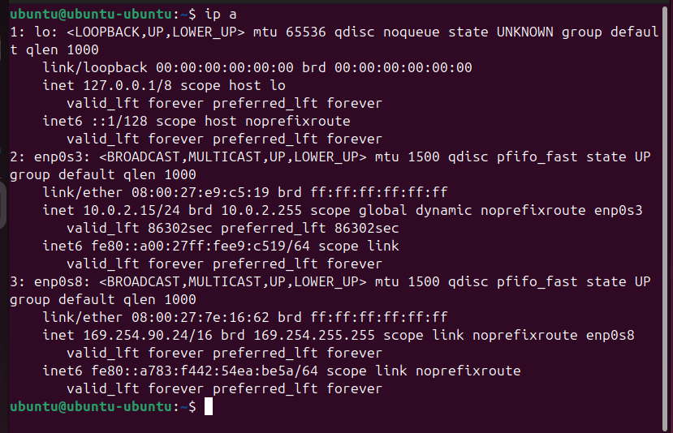

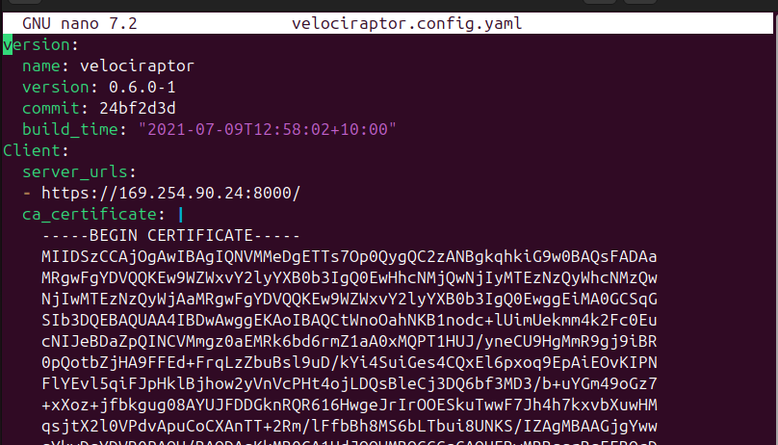

## **Creating the Administrator User**

On your Linux server, execute this command to an admin user:

**./velociraptor-v0.72-rc1-linux-amd64 --config velociraptor.config.yaml user add admin --role administrator**

When you are prompted to, enter a password you can remember.

## **Starting Velociraptor on LocalHost**

On your Linux server, execute this command, to start the server:

**./velociraptor-v0.6.0-1-linux-amd64 --config /etc/velociraptor.config.yaml frontend -v**

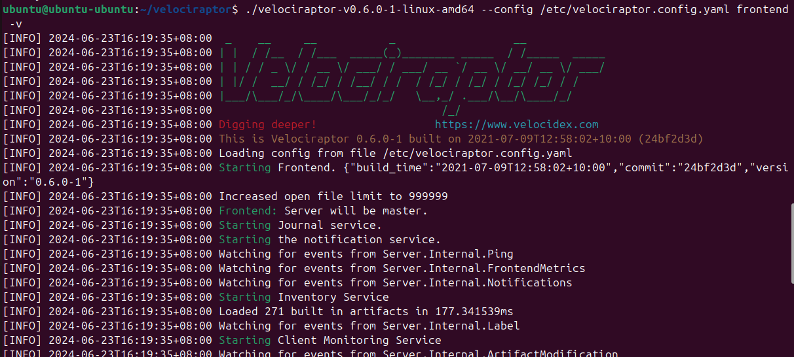

## **GUI**

Utilising a browser, enter the local host IP address and utilise port **8889.**

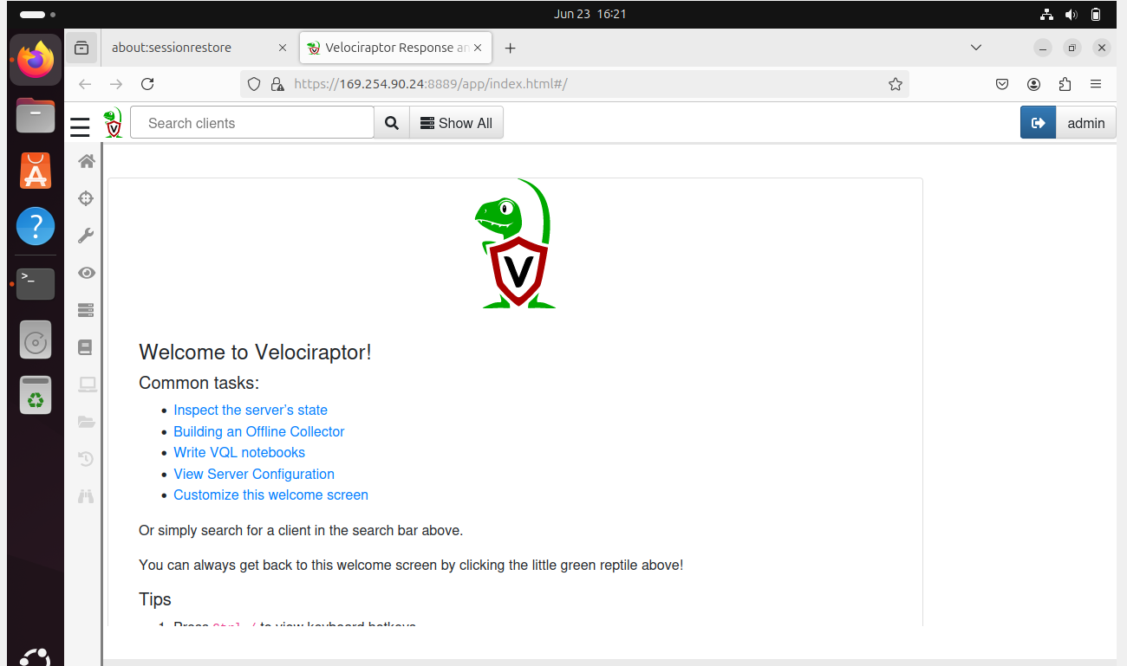

# 

# Adding a new client

**sudo nano velociraptor.config.yaml**

Scroll down to the first END CERTIFICATE line.

Below the "nonce: line, insert this line, as shown in the image below.

***CAREFULLY INDENT the line with two spaces so it matches the lines above and below it.***

**use_self_signed_ssl: true**

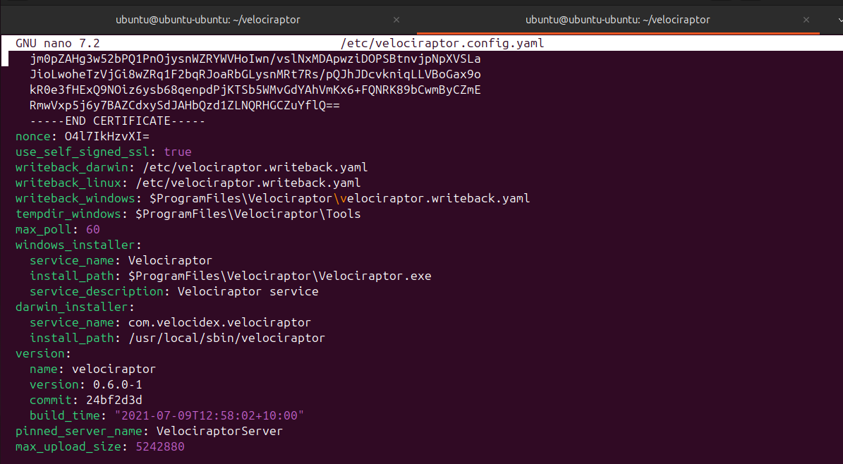

## **Preparing Windows Client**

On your Linux server, execute these commands, to prepare a client config file, download the EXE installer, and combine the two into a repackaged single-file Windows installer.

The last commands make sure your Debian server has an SSH server running.

**./velociraptor-v0.72-rc1-linux-amd64 --config velociraptor.config.yaml config client > client.config.yaml**

**wget https://github.com/Velocidex/velociraptor/releases/download/v0.72/velociraptor-v0.72-rc2-windows-amd64.exe**

**./velociraptor-v0.72-rc1-linux-amd64 config repack --exe velociraptor-v0.72-rc2-windows-amd64.exe client.config.yaml repackaged_velociraptor.exe**

**sudo apt update**

**sudo apt install openssh-server -y → Utilising theis for file transfer (WinSCP on Windows Client)**

# **Windows Machine**

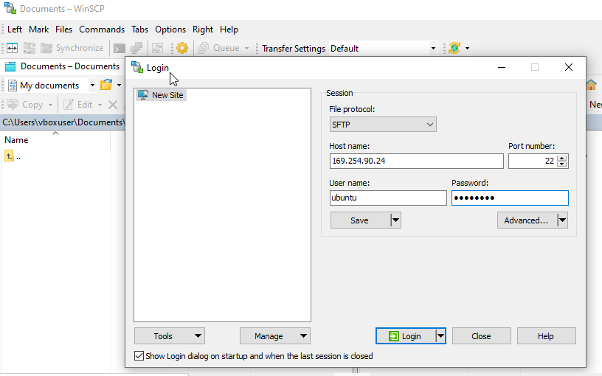

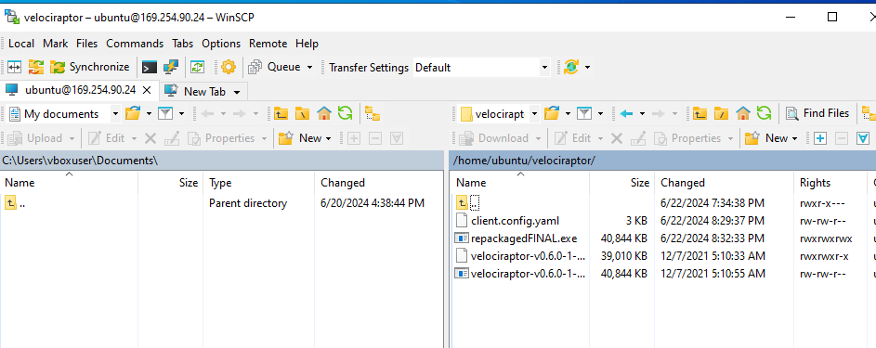

Extract the Velociraptor repackaged file into the Windows.

Open command prompt as Administrator and run the following commands:

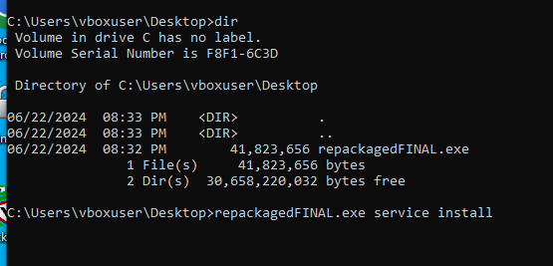

After this step, return to the Ubuntu Machine and refresh the Velociraptor GUI on the webpage and the following should be shown:

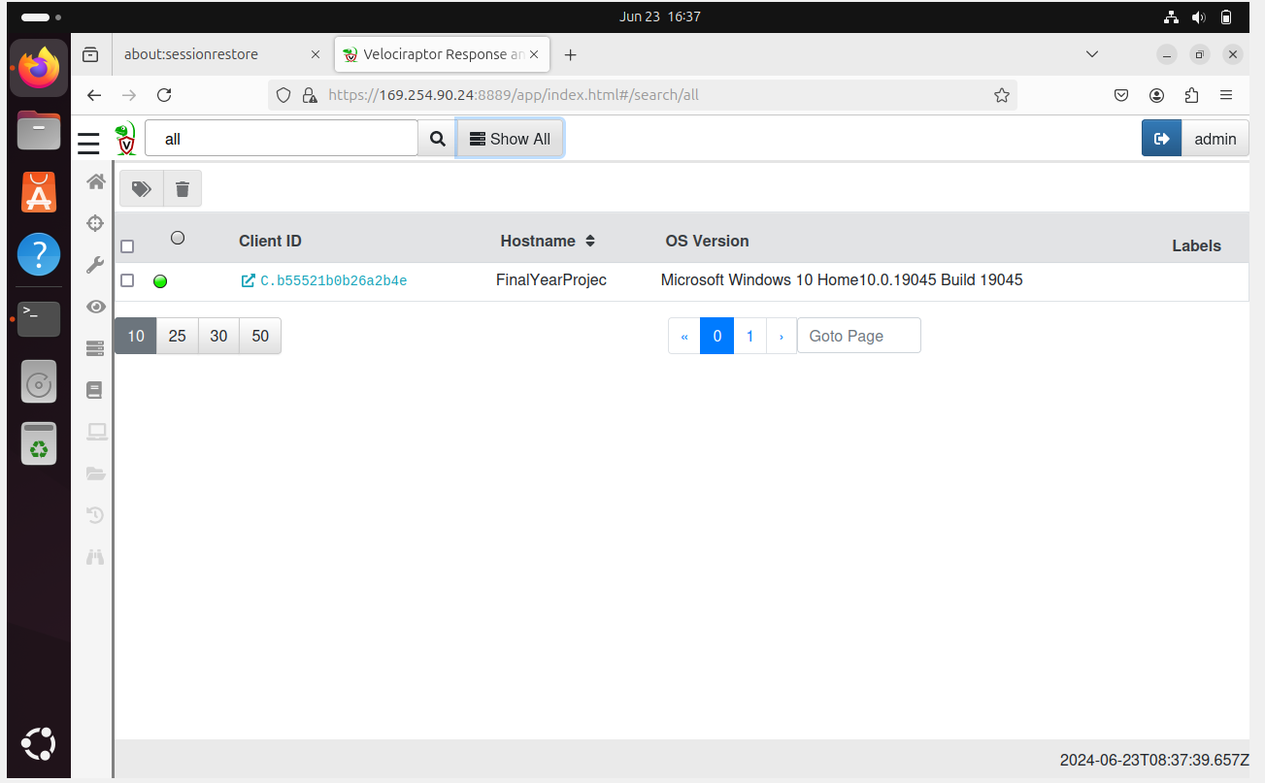

The screenshot above shows that the Windows Client has been connected successfully.

Utilising Velociraptor for Incident Response.

# Malware 1 - Reverse Shell

In order to showcase the basic functions of Velociraptor, we will be using a harmless python ‘malware’ which can be used to create a reverse shell toi the attacker machine

## Prerequisites:

* [Malware 1 Script](https://docs.google.com/document/d/1oCfn4YosgcQtHn9f4gXPpUaPvq6YoFOh1HMsltIyh_0/edit?usp=sharing)
* Download the script into a notepad and change it to .exe. Ensure that Python is installed on the Windows Machine.
* Disable Firewall and Windows Defender utilising Powershell (Admin) as shown below:

Set-MpPreference -DisableRealtimeMonitoring $true

Set-MpPreference -DisableBehaviorMonitoring $true

Set-MpPreference -DisableScanOnRealtimeEnable $true

Set-MpPreference -DisablePrivacyMode $true

Set-NetFirewallProfile -Profile Domain,Public,Private -Enabled False

Set-MpPreference -DisableRealtimeMonitoring $true

## Process:

1. Setup the Attacker’s Listener – Ubuntu Machine

Nc -lvnp 4444

1. Run the Reverse Shell Script

Run the script as administrator.

1. The following should be shown on the ubuntu Machine.

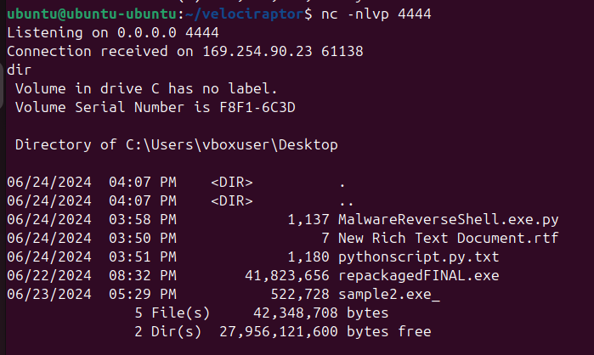

## Basic Information

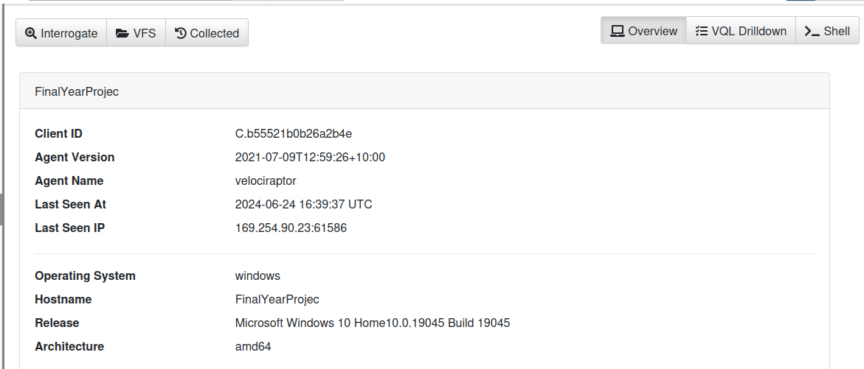

Once connected, Velociraptor is able to provide us with a short summary about the Client Machine (Windows VM).

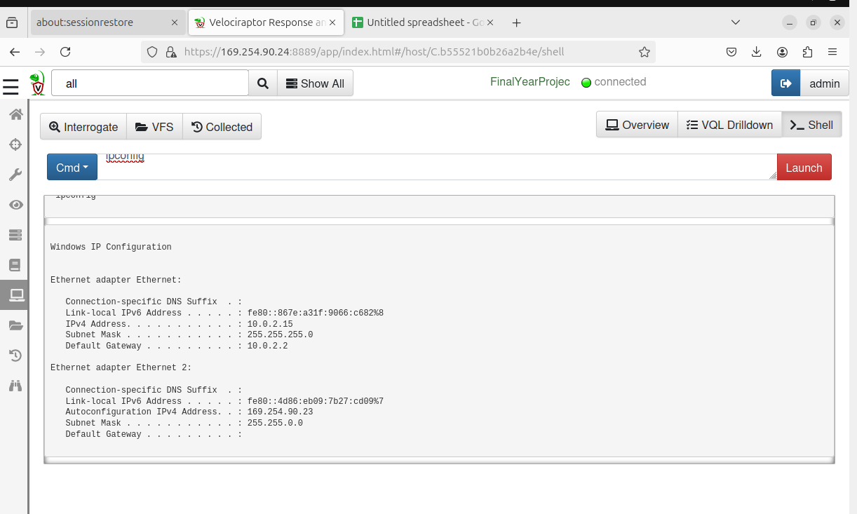

Velociraptor can also query for information utilising bash, Powershell and Command Prompt as shown above.

## Virtual File System

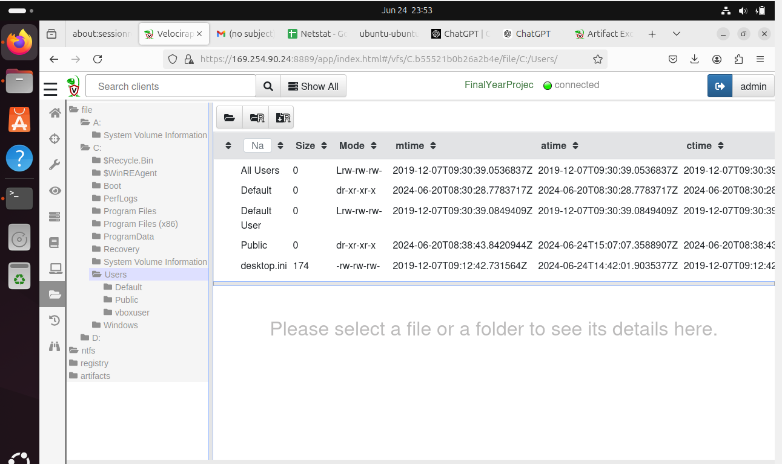

The screenshot above shows the file system of the Client Machine on Velociraptor.

Click the first button on the left to refresh.

The Virtual File System (VFS) in Velociraptor offers significant benefits for forensic investigations, incident response, and system administration by enabling remote file access and management. Key advantages include:

1. **Remote File Access:** Investigators can efficiently access and browse the file systems of remote endpoints, saving time and effort, especially when handling multiple devices.
2. **Comprehensive Forensic Analysis:** Analysts can view and retrieve files in their original state, preserving evidence integrity and accessing crucial metadata for forensic timelines.
3. **Incident Response:** Responders can quickly identify, isolate, and manage malicious files or processes, enabling swift and effective mitigation actions.
4. **System Administration:** Administrators can remotely manage files across the network, simplifying tasks like software updates, configuration changes, and log collection.
5. **Versatility and Flexibility:** VFS supports various tasks such as file retrieval, script uploads, and automated updates, enhancing operational efficiency.
6. **Security and Compliance:** Secure access controls and audit trails help maintain data confidentiality and ensure compliance with security policies and regulations.
7. **Scalability:** Velociraptor's VFS can handle numerous endpoints, making it suitable for large-scale environments and diverse organizational needs.

# Notebooks

In Velociraptor, notebooks are used to create and execute custom analysis scripts and queries against collected endpoint data. Notebooks provide a flexible and interactive way to explore and analyze data gathered by Velociraptor agents across endpoints. Here's how notebooks are typically used in Velociraptor:

Data Analysis and Exploration: Analysts can write Python scripts within notebooks to query and analyze data collected by Velociraptor agents. This includes examining file metadata, process information, network connections, and other endpoint telemetry.

Custom Querying: Notebooks allow users to create custom queries using Velociraptor's query language. This can involve filtering and aggregating data to identify specific patterns or anomalies across endpoints.

Visualization: Notebooks support the creation of visualizations such as charts and graphs to help in interpreting data trends and patterns visually.

Incident Response and Investigations: During incident response, notebooks are valuable for running ad-hoc queries to gather forensic evidence and perform detailed analysis of potential security incidents.

Collaboration and Documentation: Notebooks serve as documentation of analysis steps and findings, making it easier to share insights with team members and stakeholders. They can include comments, annotations, and explanations alongside code and results.

Automation: Notebooks can be used for automating repetitive tasks or analysis workflows. This can streamline investigations and response efforts, especially in environments where rapid analysis and decision-making are critical.

## Utilising Artefacts for Information Gathering and Investigation

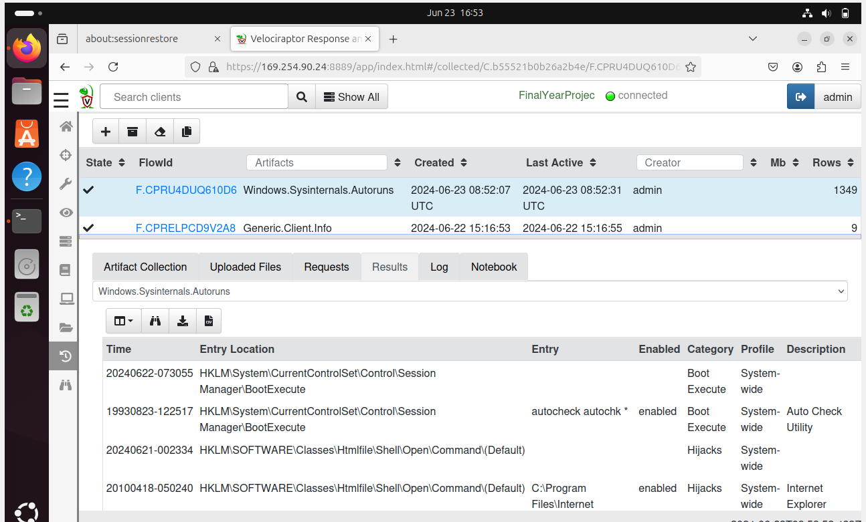

This is an example of using the artifact “Windows.Sysinternals.Autoruns” for incident response.The .CSV version can be downloaded and imported into Google Sheets or Microsoft Excel.

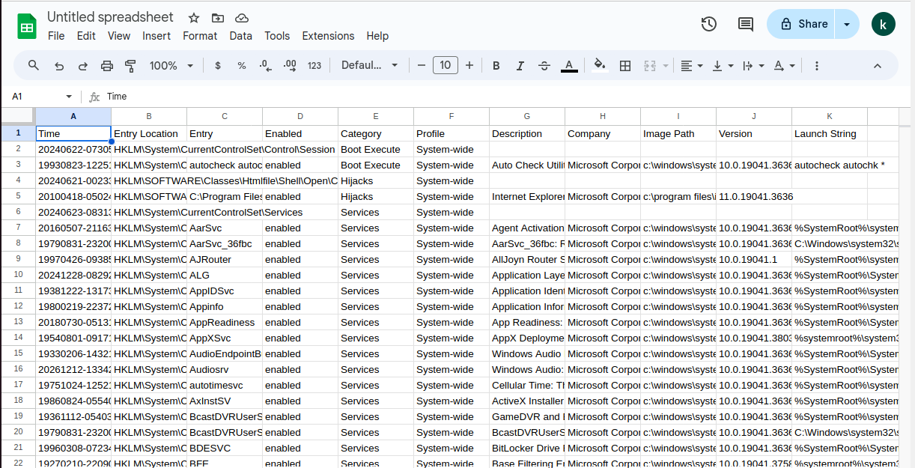

Now that the reverse shell has been created, run the Velociraptor Artefact “Windows.Network.Netstat” .

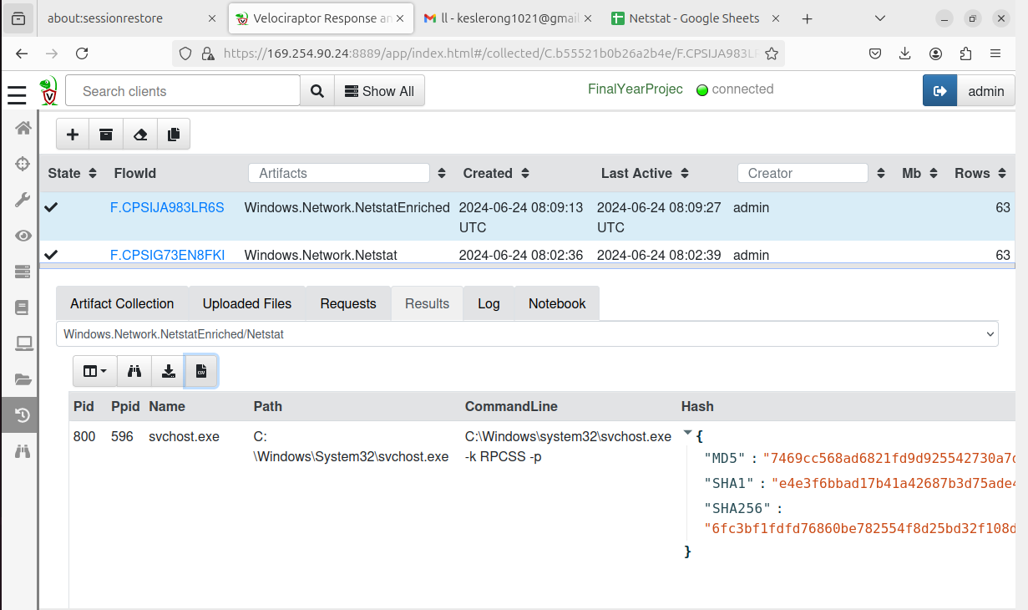

After the process has been completed, download the CSV file and open the file in Google Sheets or Microsoft Excel.

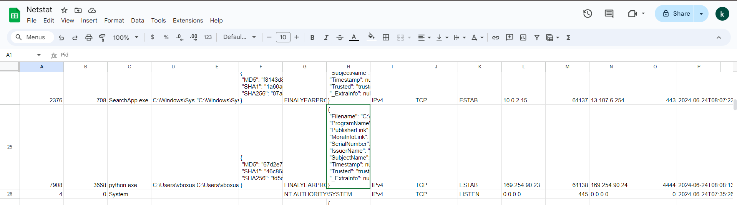

From the screenshot above, we are able to see on line 25 that a connection has been established on port 4444 from 169.254.90.23 (Windows) to 169.254.90.24 (Ubuntu).

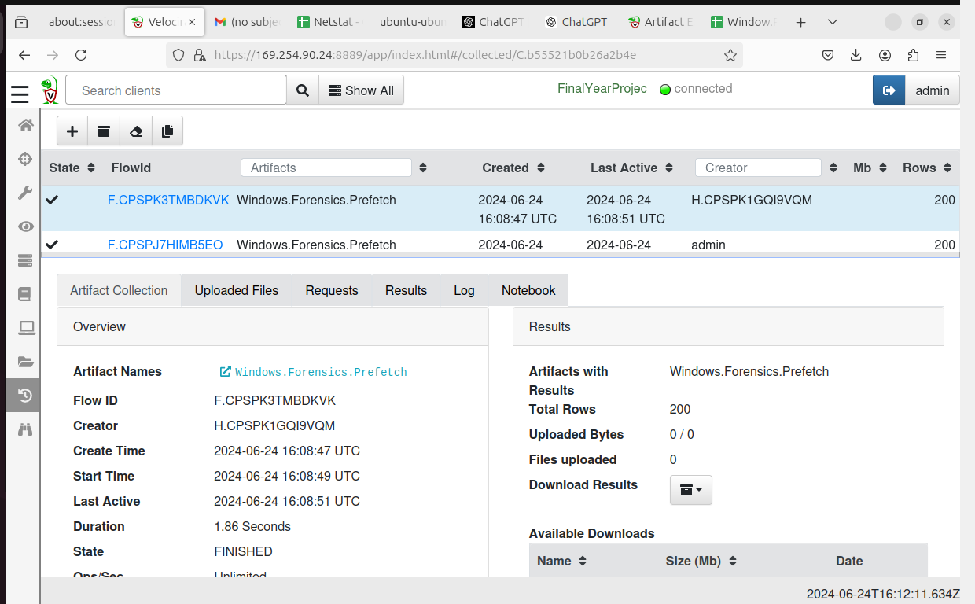

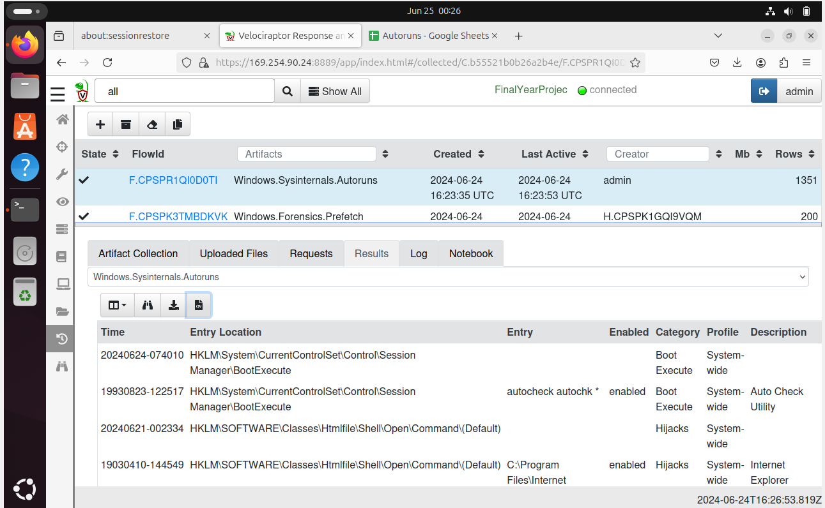

Utilising the “Windows.Sysinternals.Autoruns”, we are able to investigate if the malware has startup capabilities.

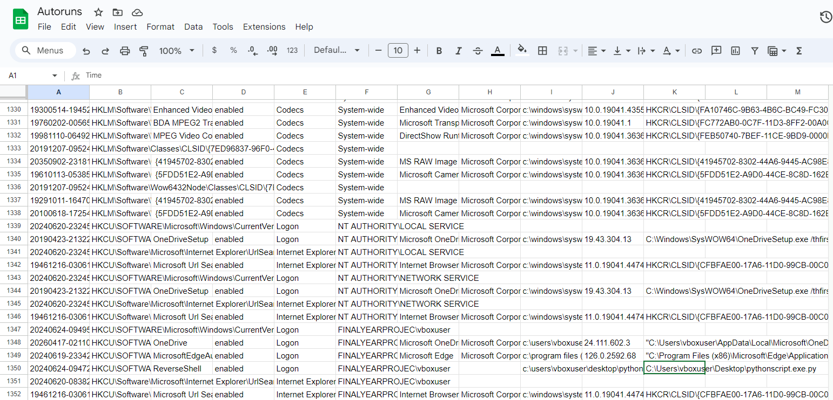

The screenshot above shows the results that on line 1350, we are able to observe that “ReverseShell” with the filepath to the Python Script (Malware) is shown. This confirms the malware’s startup capabilities.

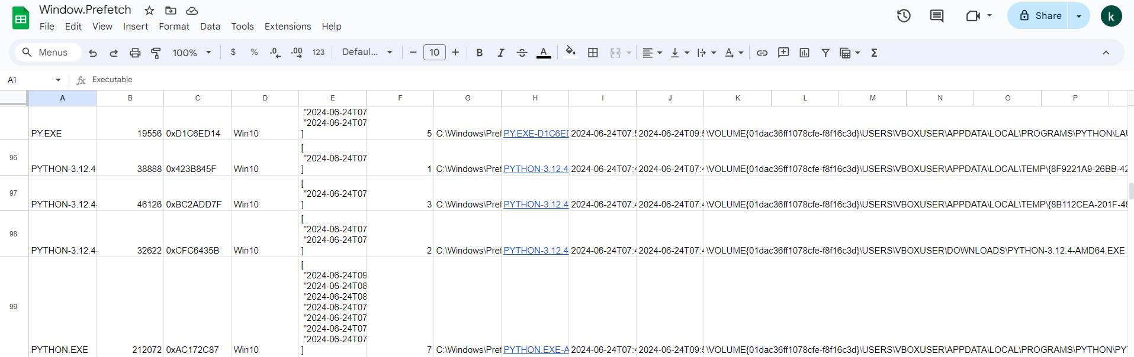

Prefetch is a Windows feature that helps to speed up application launch processes. When an application is run for the first time, the WIndows Operating System creates a prefetch which contains information about files that the application accessed during the startup. This data helps Windows to optimise loading of these files the next time the application is launched to reduce startup time.

## Utilising Hunt Feature in Velociraptor

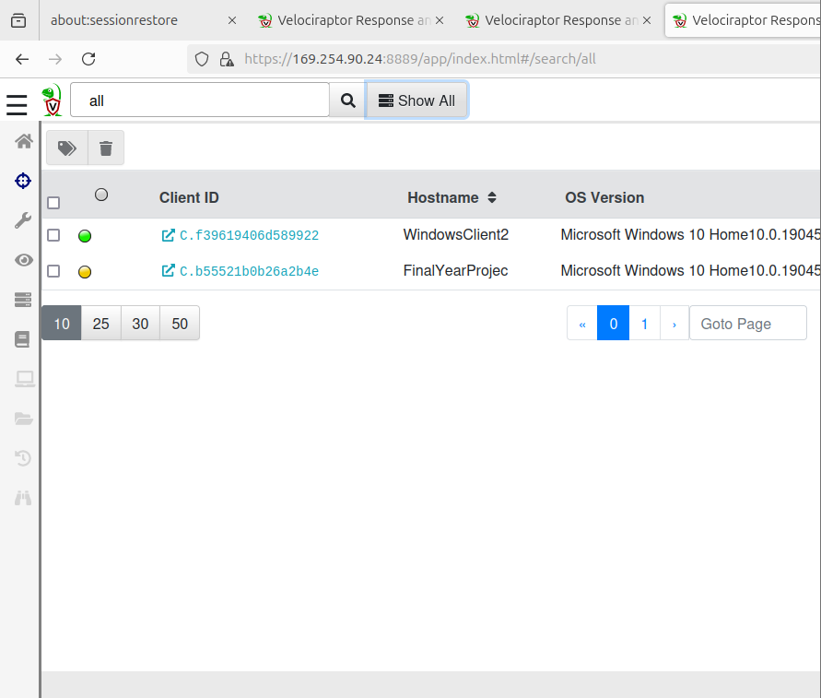

As seen in the above screenshot, it can be seen that we have connected a second end-device for the hunt which is mainly utilised for multiple end-devices.

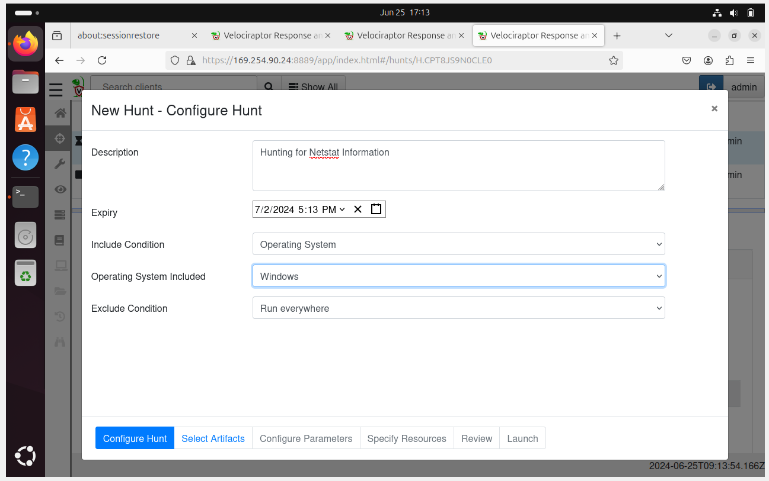

When configuring a hunt, the type of Operating System and an excluding condition can be set in order to maximise efficiency. For this case, since 2 Windows Machines are being used, we will include only Windows Operating Systems.

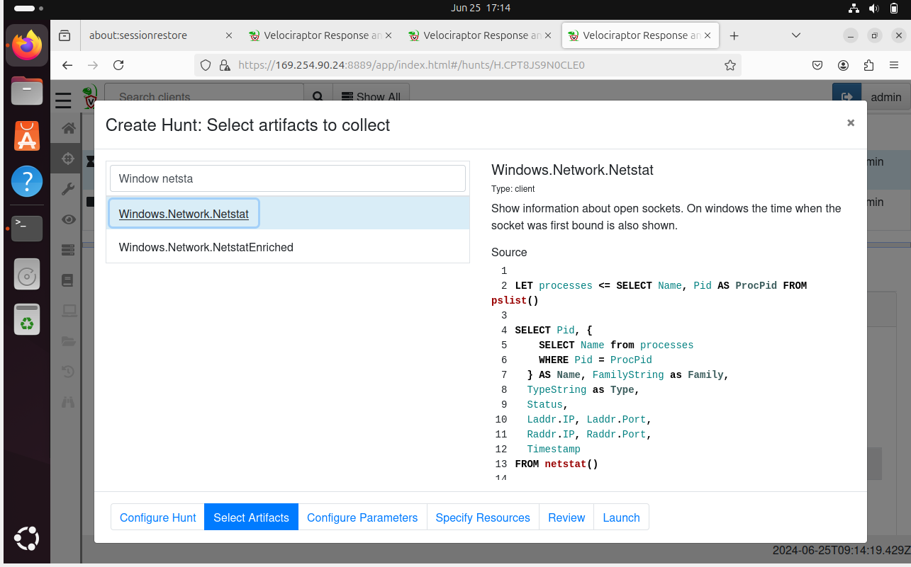

For this hunt, the artefact “Windows.Network.Netstat” will be used to inspect Network Traffic information. Next, click the “Launch” button to run the hunt.

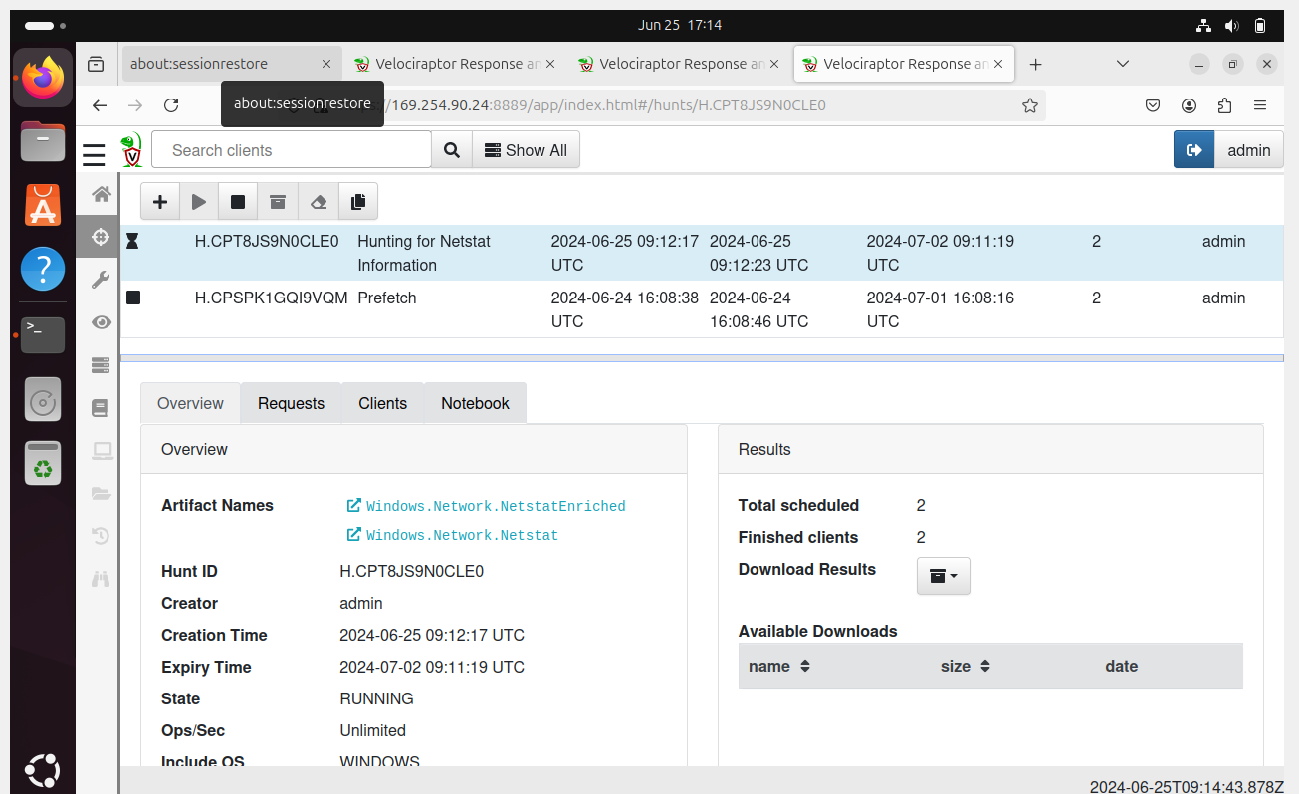

Ensure that the Play button has been clicked and the hunt will run as expected.

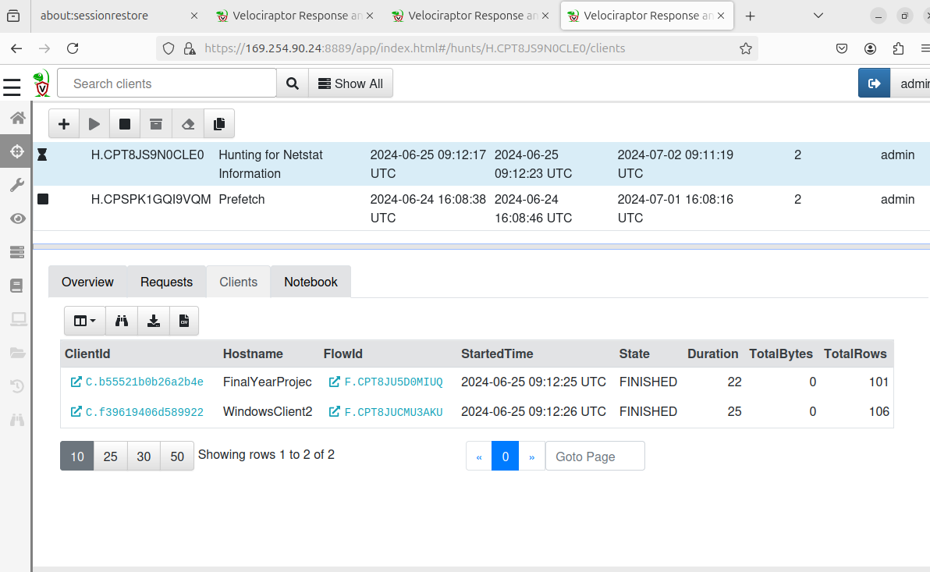

Switch to the clients tab, the status of the process will be displayed.

Results

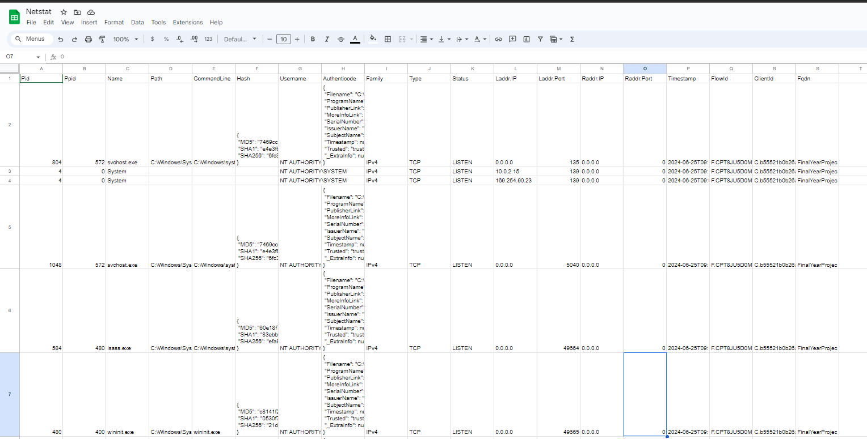

## Hunts vs Artifacts

In general, artifacts are building blocks defining what data to be collected and how it is being collected. However, Hunts are the execution framework that deploys the artidacts across multiple end points to gather data at a larger scale. This can be efficient for companies due to its scalability.

**Artifacts**

Artifacts are predefined sets of queries and script that can be used to collect data from a singular endpoint. They can be used for the following purposes:

*Data collection*. The artifacts provided inside of Velociraptor can be used to gather specific information from endpoints such as log files and system configurations which can be to help for incident response.

*Custom Artifacts.* Users are able to create and modify artifacts based on their specific needs.

**Hunts**

Velociraptor has the function for deploying artifacts across multiple endpoints which is deemed to be helpful in a larger scale organisation. They allow for large-scale data collection and analysis by being able to distribute and executing artefacts on many endpoints simultaneously.

This is helpful as it can be deployed on a larger scale to execute artifacts across a fleet of endpoints which facilitate large-scale investigations and monitoring. For example, a Cybersecurity Expert is able to run a specific artifact to collect data related to the hive registry on various company laptops using Velociraptor for an investigation.

Hunts are also automates the process of running artifacts on multiple machines for the collection of results for analysis.

## Finding Persistence on Infected End Devices

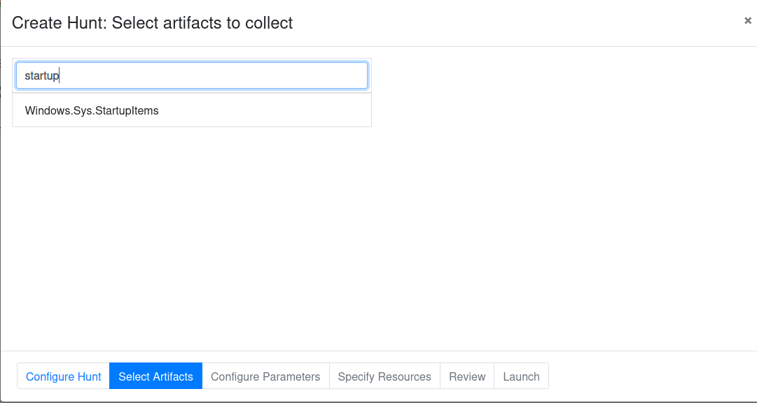

In order to investigate for any persistence mechanisms by the malware, the artefact “Windows.Sys.StartupItems” can be used during the hunt in order to identify programs and scripts that are set to run automatically when Windows starts.

The artfact examines registry keys, startup folders, scheduled tasksand other mechanisms that malware 1 may have used to maintain persistence on the system. This is able to provide investigators with a comprehensive list of startup items which could help to pinpoint any suspicious and unauthorised entries.

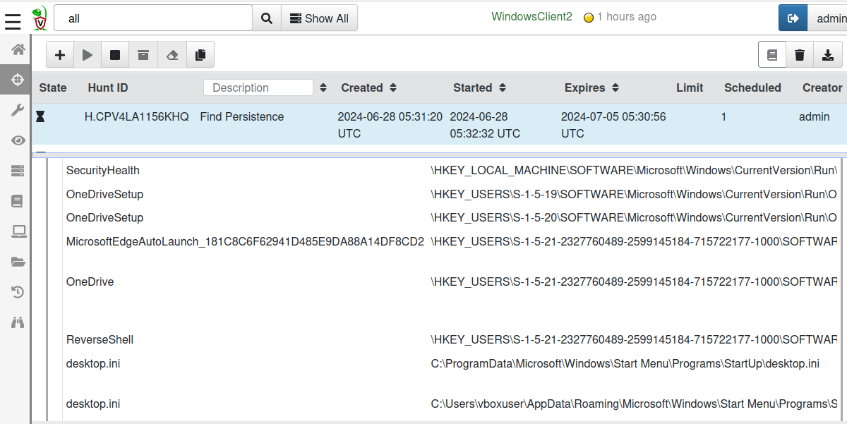

The screenshot above shows a startup named “ReverseShell” which is deemed to be suspicious as it could be related to malware 1. The registry key location has also been identified as shown.

## Finding persistence within Task Scheduler

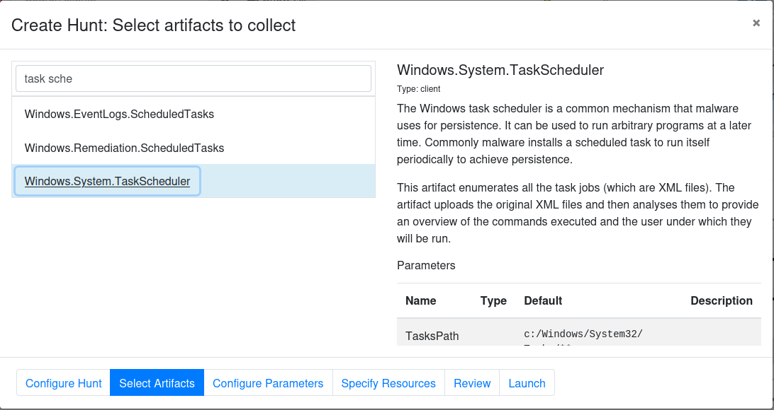

Next, another hunt can be created and the artefact used would be “Windows.System.TaskScheduler” in order to identify any persistence within task scheduler.

Task Scheduler is a component within Microsoft Windows which is able to provide the ability to schedule the launch of programs or scripts at predefined times. Scheduled tasks are often used by Malware

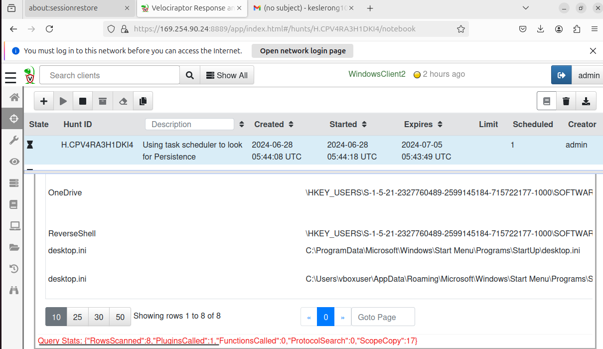

## Autoruns for Persistence

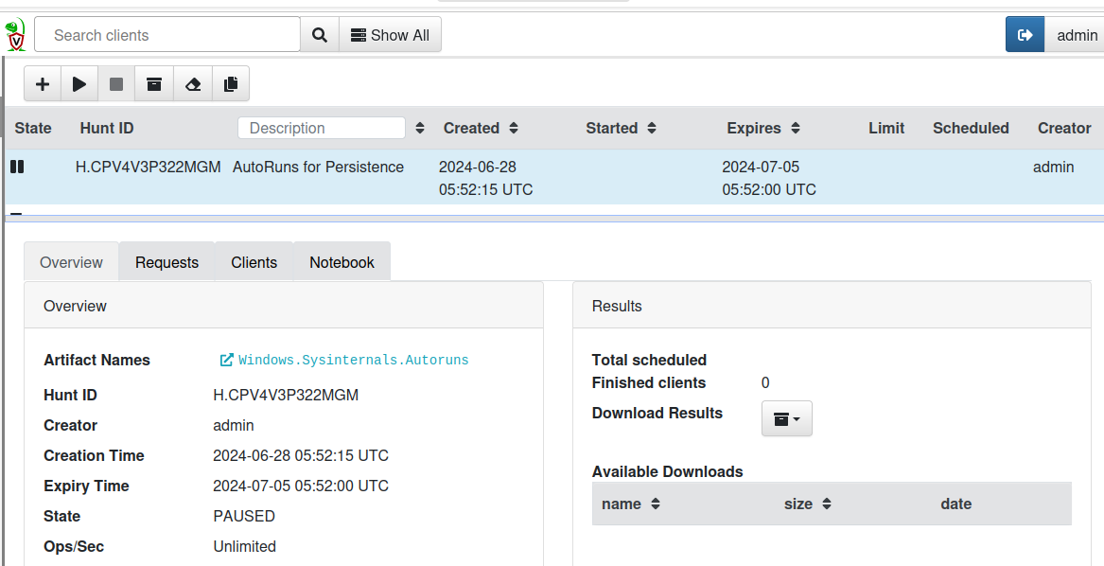

## Implementing Virustotal in Velociraptor to Flag Malicious Files:

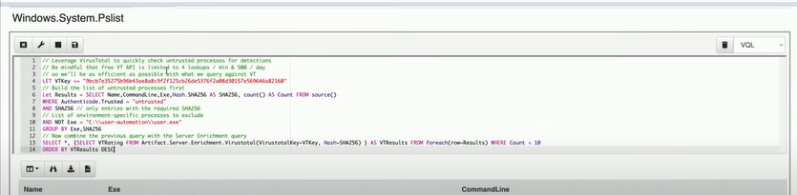

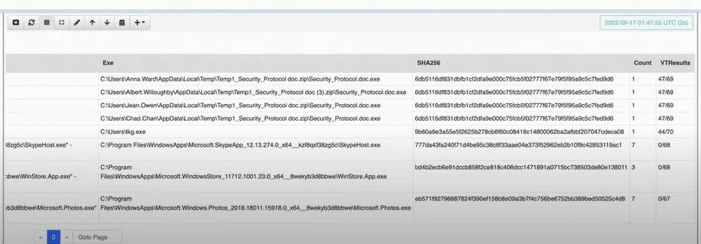

## Containment and Mitigation

Velociraptor can be used to perform remote actions on compromised endpoints, such as isolating systems from the network, terminating malicious processes and removing malicious files during analysis

Apply temporal fixes and mitigations to minimise further damage that is done whilst the investigation is ongoing.

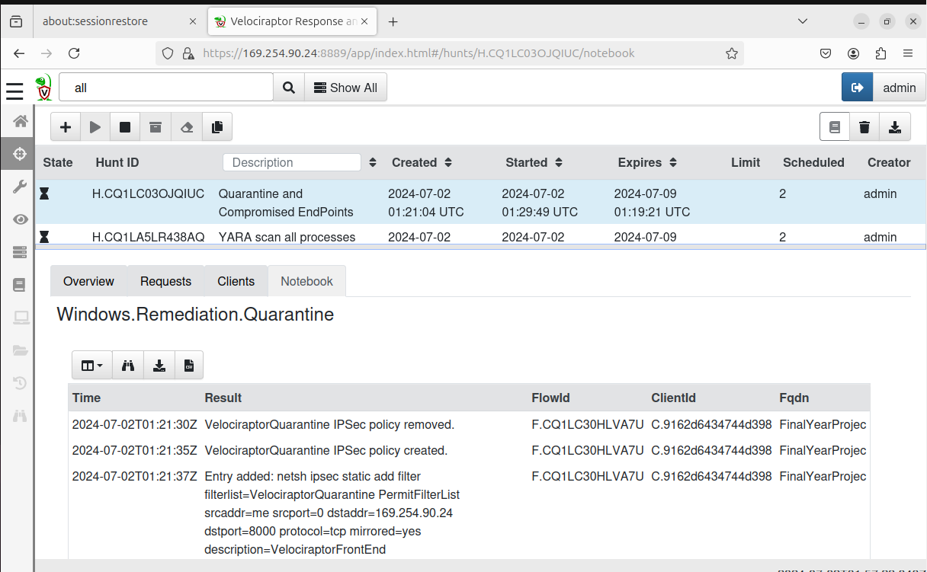

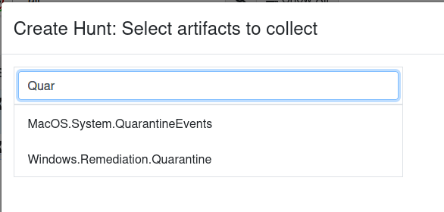

In order to ensure mitigation and containment of the Malware Sample, the artefact “Windows.Remediation.Quarantine” would be used.

The Windows.Remediation.Quarantine artifact in Velociraptor is designed to contain and mitigate malware threats on a Windows endpoint. It isolates suspicious files by moving them to a designated quarantine directory, preventing their execution while allowing for further analysis. Additionally, the artifact can terminate malicious processes, ensuring that they do not continue to run or spread.

To combat persistence mechanisms, it can modify or delete registry keys and other auto-start entries that the malware might use to restart after a system reboot.

The artifact also has the capability to apply network isolation, blocking the infected endpoint's communication with other systems to contain the spread of the malware. Furthermore, it logs all actions taken, providing an audit trail for analysis and verification. This tool is particularly useful during incident response to quickly neutralize active threats and in proactive containment strategies to manage potential risks identified during threat hunting or routine scans.

By employing the Windows.Remediation.Quarantine artifact, security teams can effectively manage and mitigate malware, aiding in the swift recovery and remediation of compromised systems.

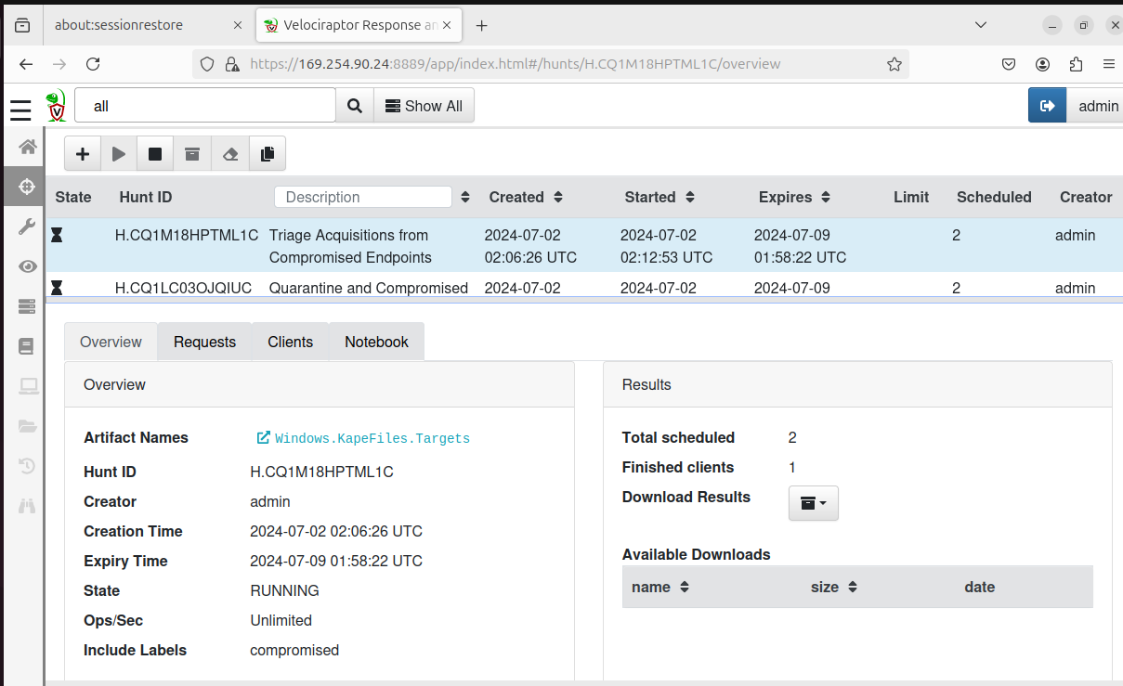

Another method of containment and mitigation can be done by triaging acquisitions. This can be carried by running a hunt utilising the artefact “Windows.KapeFiles.Targets”. This artifcat leverages KAPE (Kroll Artifact Parser and Extractor) targets to swiftly collect specific forensic artifacts from a Windows system, facilitating rapid identification of malicious activities and enabling immediate containment actions.

Targeting critical forensic artifacts such as event logs, registry hives and prefetch files, it helps build a comprehensive picture of system’s state and any activity which deemed to be suspicious.

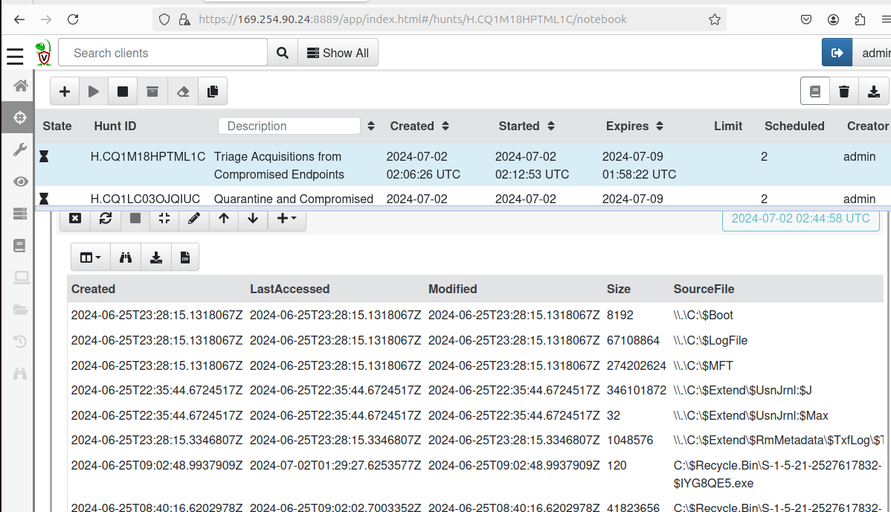

From the screenshot above, we are able to see to retrieve event logs such as the last accessed, created and modified timestamps. Furthermore, the filepaths of the sourcefiles are also provided.

Records of user logons and logoffs can help trace user activity and potential unauthorised access on the system. Furthermore, there are executables and DLLs that are often targetted by the malware can also be analysed to allow for deeper analysis of potential malicious binaries.

# Utilising Velociraptor for investigations

<https://drive.google.com/drive/folders/1bGrHjdX_xkCzQaW3n-_OLRKyz3JPhCVu?usp=drive_link>

The malware/viruses used in the following investigations can be found inside the Google Drive Link above.

## Investigation 2 – pup4

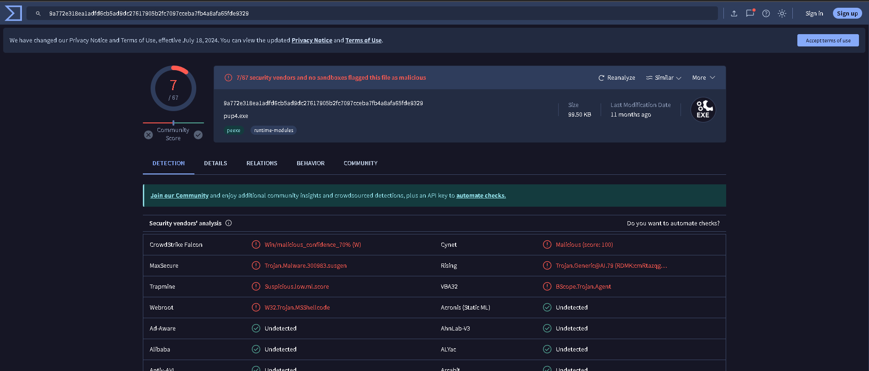

What is a PUP?

It stands for Potentially Unwanted Program.

Even though not all PUPs are malicious, PUPs are able to exhibit behaviours that can be considered to be intrusive and unwanted. The programs can be bundled with other softwares which can lead to inadvertent installation. PUPs are known to possess the followintg characteristics:

* Displaying unwanted programs
* Modifying system settings
* Collection of user data
* Bundled software - comes bundled with freeware or shareware, making it difficult to avoid during installation.

Right-click pup4.zip. Click "Extract All...". Click Extract. Use the password "**malware**".

3. Run pup4\pup4\pup4.exe as administrator

4. Move pup4\pup4\pup4message.exe to C:\

5. Delete pup4.zip and the pup4 folder. Empty the Recycle Bin.

6. Restart your machine. If an "Open File - Security Warning" box pops up, uncheck the "Always ask before opening this file" box and click Run. 7. An irritating message pops up, as shown below.

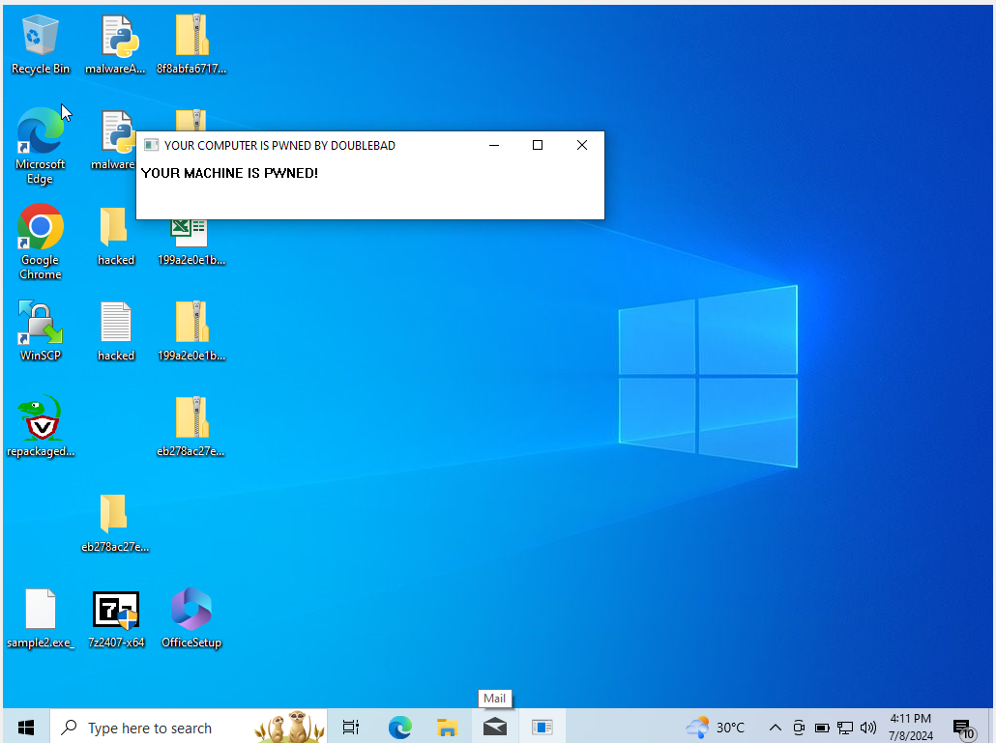

As shown in the screenshot above, a message “**YOUR MACHINE IS PWNED!”** is being diosplayed. This can be categorised under PUP as such characteristics are known to be intrusive and unwanted.

In many cases, these messages are known to cause users to be alarmed and annoyed. Despite teh PUP not having significant consequences, the malware is able to negatively affect the user experience and system performance.

However, Velociraptor can be deployed to effectively detect and mitigate the presence of PUPs.

### Autostarts

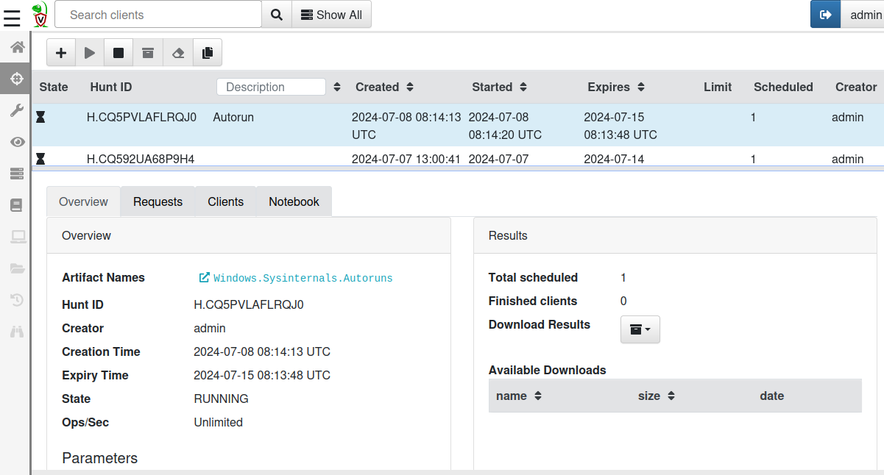

Utilising Velociraptor’s hunt feature, we are able to utilise the artefact “Windows.Sysinternals.Autoruns” to identify the PUP that is started automatically on system startup.

This artefact is able to leverage Sysinternals.Autoruns to provide valuable information about auto-starting locations on the Windows System.

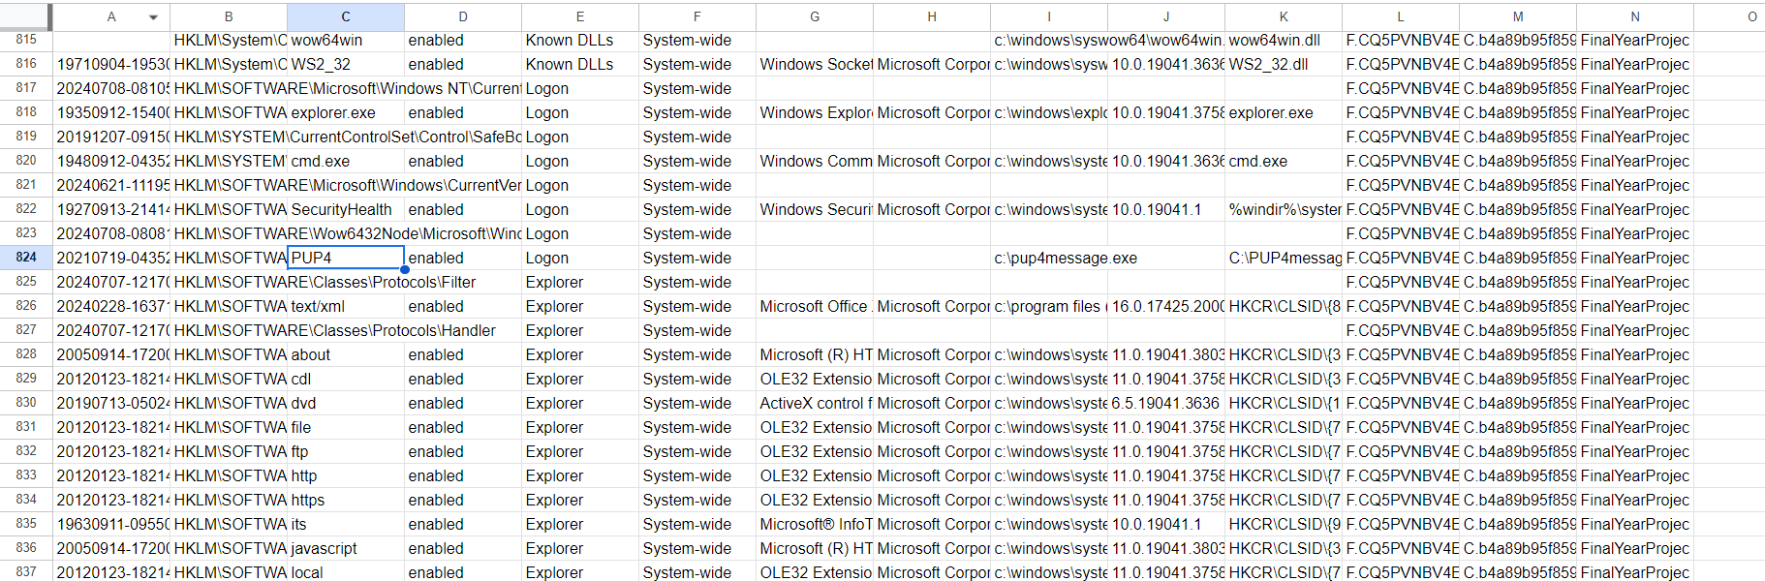

The screenshot abovedisplays the results from the hunt. The key **HKLM\SOFTWARE\Wow6432Node\Microsoft\Windows\CurrentVersion\Run\PUP4** is deemed to be suspicious due to the following reasons:

* Running from C:/ as Root

Legitamate applications are usually installed in specific directories designated for program files for best practices for organisation and security. The programs running from root directories may be attempting to avoid detection methods.

* Not known system utility

Unrecognized programs that are configured to run at startup without user consent or clear documentation often indicate PUPs or other unwanted software.

* Not signed by Microsoft

A digital signature is a way of verifying the authenticity of software. Microsoft and other reputable companies sign their software in order to assure users that the software is legitimate and has not been tampered with.

### Process List

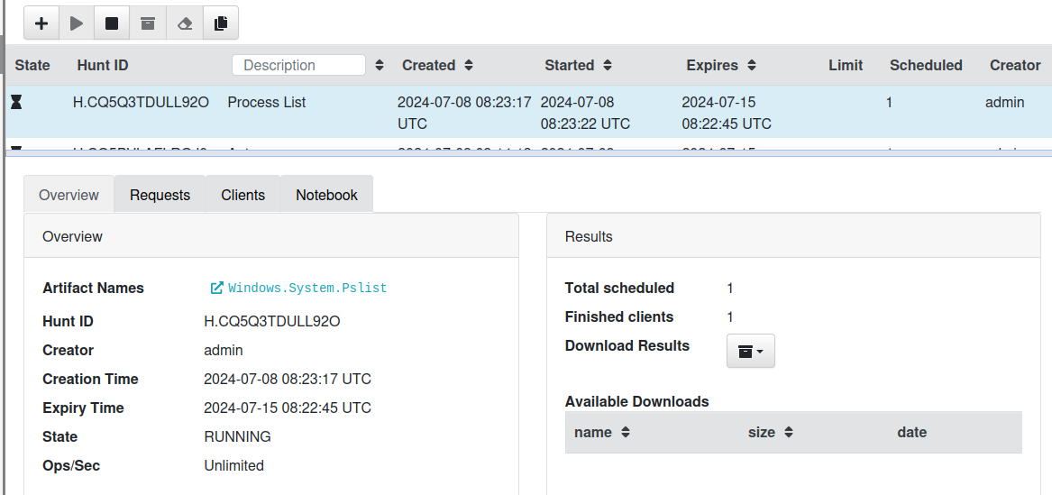

Utilising the “Windows.Systems.Pslist” artefact is able to provide detailed information which can help in the investiagtion of the PUP. The artifact identifies the process, process ID, name, filepath and parent process. This information can all be utilised to help trace how the PUP was initiated in the first place and identifying its source. The execution status also suggests that the process is not running with elevated privileges which suggests that there may have limited impact on the system.

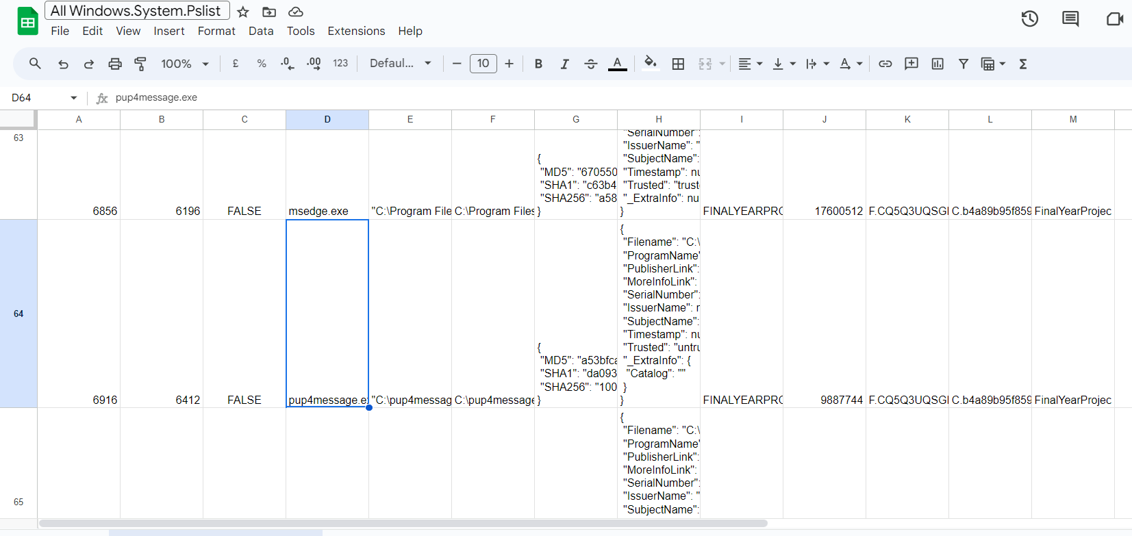

The hash information obtained can also enable further research using online databases such as Virustotal to determine whether the executable is deemed as suspicious or not.

The authenticode information shows the file is unsigned, indicating it has not been verified by a trusted source, a significant indicator of potential harm. The user context reveals which user account (FINALYEARPROJEC\vboxuser) ran the process, helping identify who may have installed or executed the PUP. Additionally, the memory usage detail (9887744) might indicate unwanted behavior if the PUP consumes significant resources.

### Process Dump

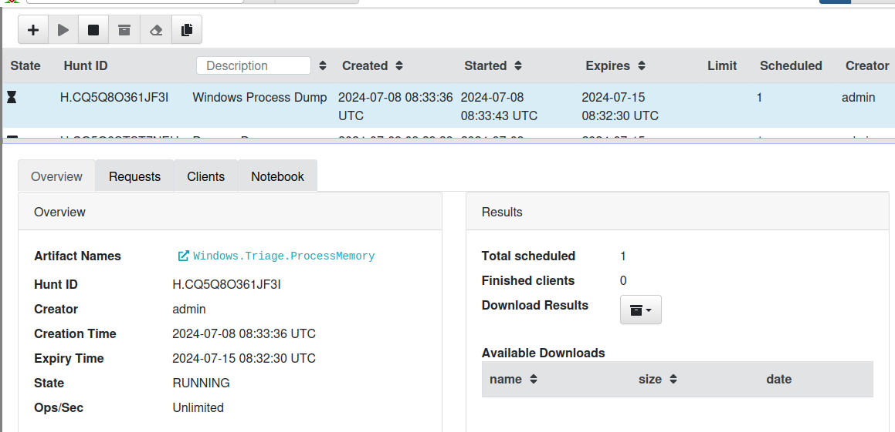

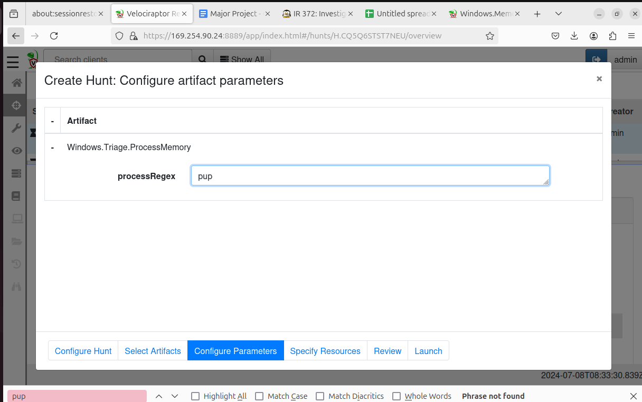

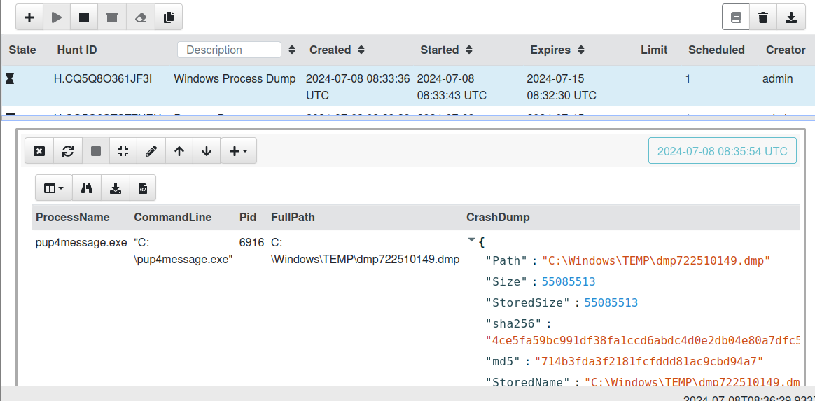

The artefact “Windows.Triage.ProcessMemory” is able to serve as a crucial tool which can be used to capture memory of specific processes, allowing investigators to delve deeper into their runtime behaviour and contents.

By analysing the process memory, analysts are able to uncover critical details such as hidden code, encrypted data and network communication which indicates malicious activity. By capturing this memory, investigators are able to insights into the potential threats posed by the process. This capability therefore plays a crucial part in detecting malware and understanding the extent of security incients.

### Remediation

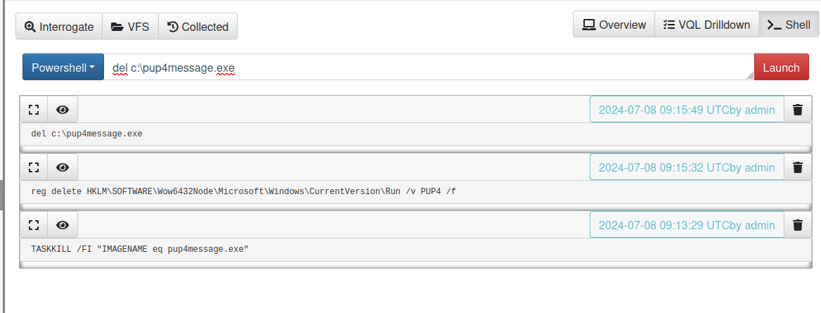

IIn order to carry out the remediation process, Velociraptor will be used to run commands remotely on Powershell and CMD. Tjis capability allows administrators to swiftly and effectively address security threats and issues without requiring physical access to each endpoint.

“TASKKILL /FI "IMAGENAME eq pup4message.exe” command terminates the process associated with the ‘pup4message.exe”. This ensures that the malicious program is to be stopped immediately.

‘reg delete HKLM\SOFTWARE\Wow6432Node\Microsoft\Windows\CurrentVersion\Run /v PUP4 /f’ This command removes the registry entry responsible for teh autorun of the ‘pup4message.exe; at system startup. By deleting the registry key, the PUP is unable to be executed again when the system reboots which removes its persistence mechensim.

‘del c:\pup4message.exe’ This command deletes the actual executable file in the C:\. This ensures that the executable is removed from the system entirely

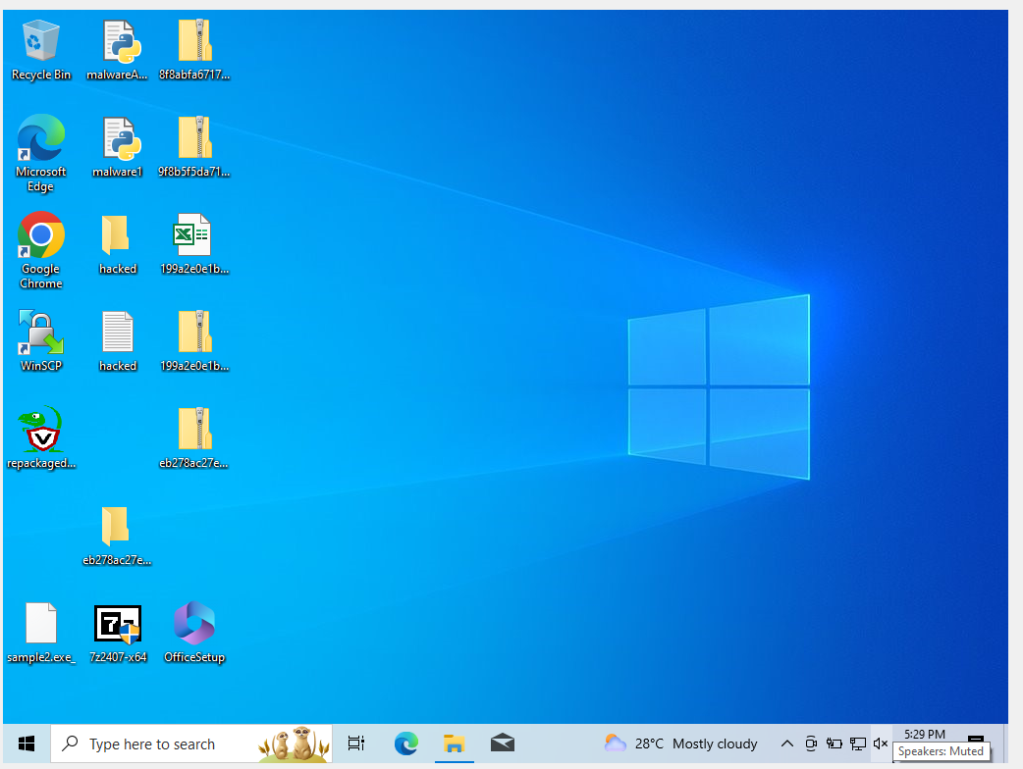

As shown above, the PWN Message is no longer shown after restart.

## Post Incident Review and Reporting

Following the containment and mitigation of Malware using Velociraptor, a thorough post-incident review is required to document all incidents of the investigation from lessons learned, recommendations and further improvements that can be made.

*Incident Overview: PUP4*

1. Lessons Learned

This security incident managed to highlight the importace of the robust detection mechanisms and how it needs to improved. Enhancements in monitoring registry entries and suspicious process behaviour can improve early detection of similar threats in the future.

User Awareness. This is another factor that may have contributed to this security incident. It is crucial to educate users about the risks of downloading and executing unknown programs which can be prevented with more user awareness.

1. Recommendations

Regular Vulnerability Assessments can be carried out can proactively identify and mitigate potential security weaknesses.

Implementing a stronger endpoint protection measures can be carried out utilising advanced threat detection tools and real time monitoring to ensure protection against malware intrusions.

1. Further Improvements

Advanced training and drills for the incident response teams can be done to improve readiness and effectiveness in handling future security incidents.

# 

# Investigation 2

This sample disables Windows Defender and Windows Firewall, downloads a second stage, and runs a Bind shell listening on port 444.

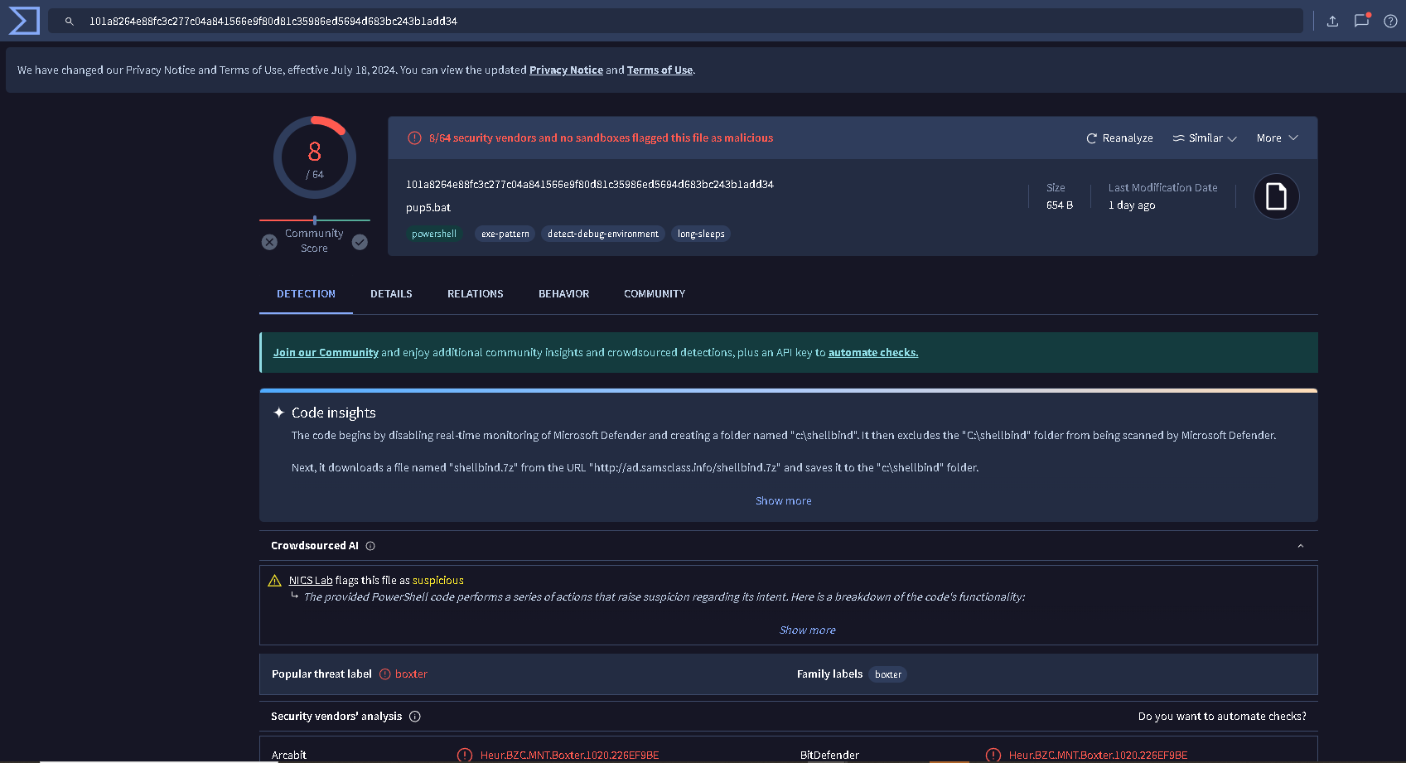

## Auditing Network Connections

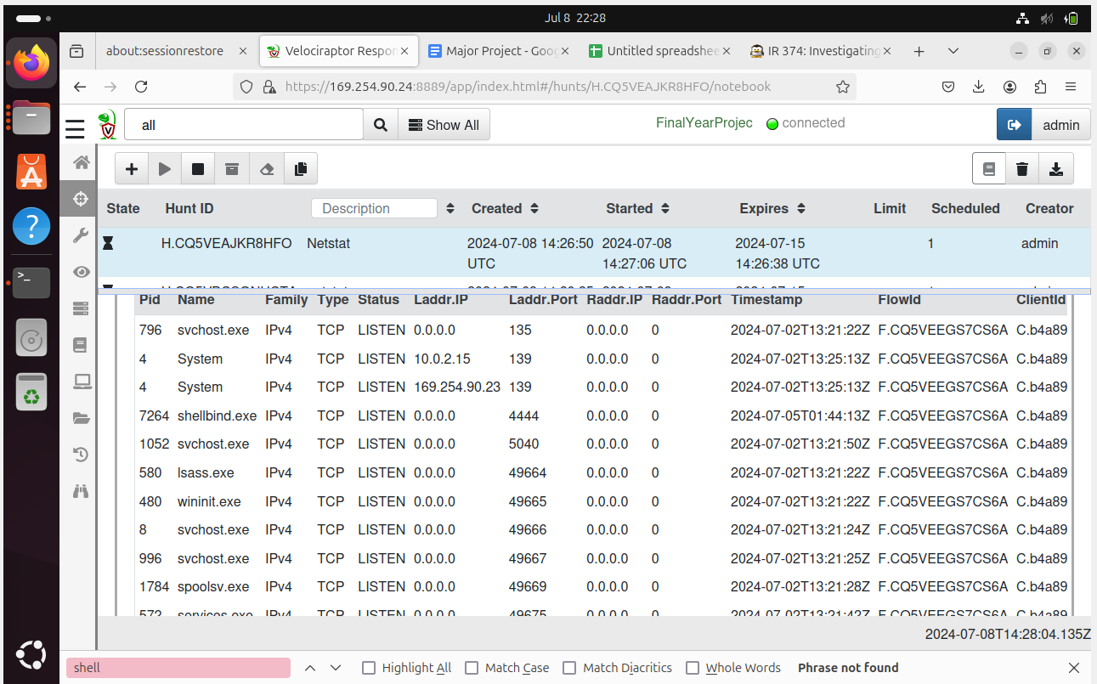

The process shellbind listening on port 4444 which can be considered suspicious as it is the default port for metasploit.

## Autoruns

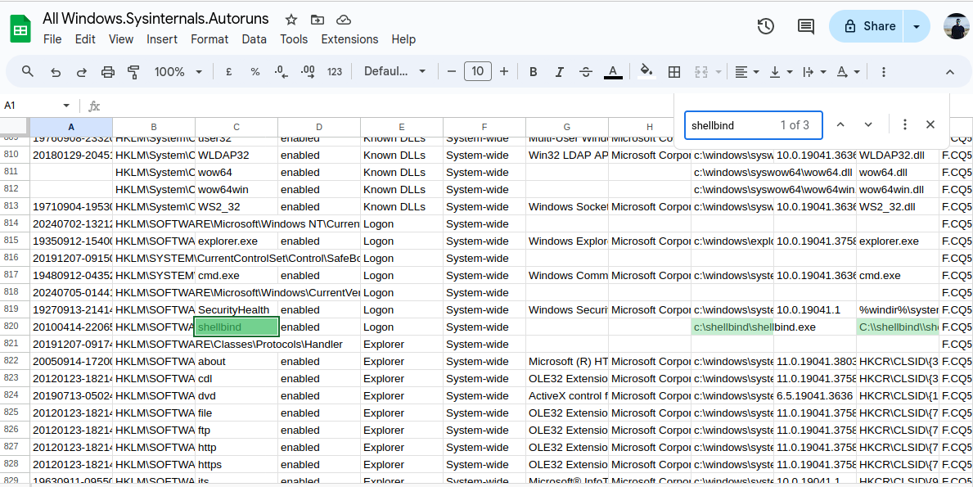

Registry key HKLM\SOFTWARE\Microsoft\Windows\CurrentVersion\Run\shellbind

C:\shellbind\shellbind.exe

## 

## Creation TIme

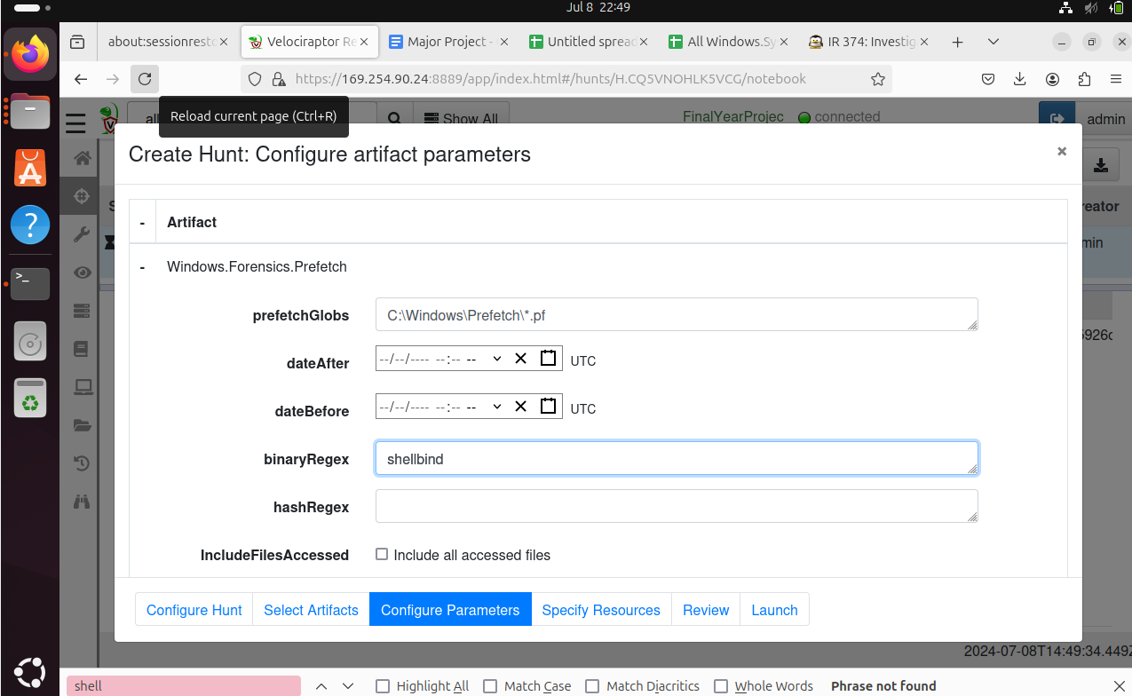

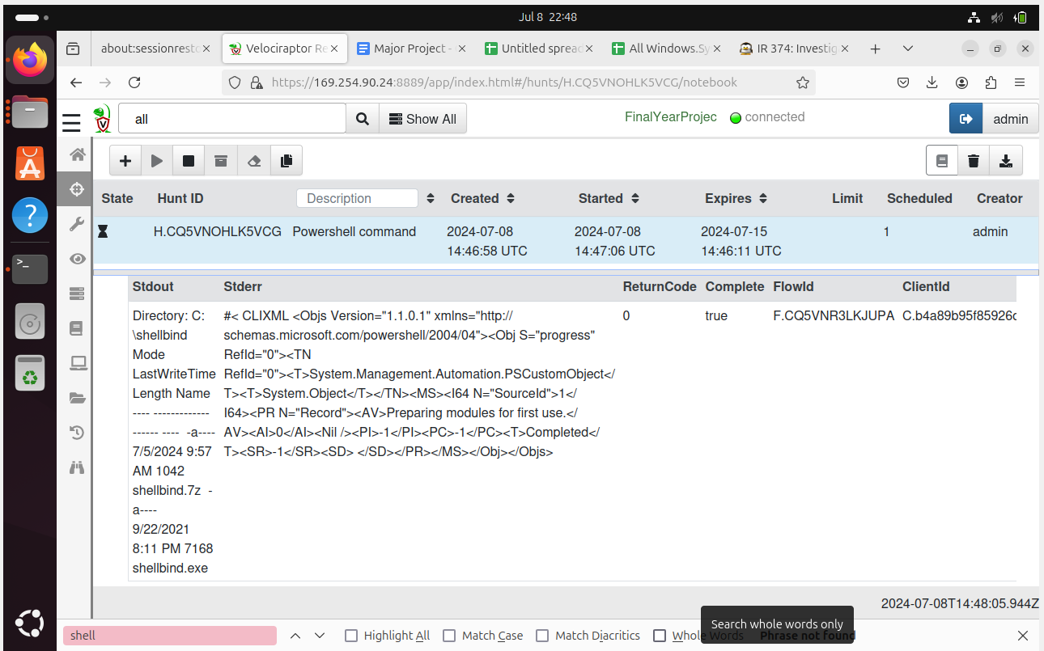

Using the “Windows.System.Powershell” with the parameters configured as “shellbind”, the result as shown above displays information such as the filenames, their sizes, and timestamps (created, modified, accessed) for all files within that directory.

This data can be used to identify the time of the attack, providing a key piece of information for further log analysis and investigation to create a sequence of events leading up to and following the attack. This data will help correlate events across different logs and understand the timeline of the attack.

## Prefetch

Prefetch is a performance optimisation feature by Windows Operating Systems which is able to store information about frequently executed programs. When a program is run, the system creates aPrefetch file which includes metadata abouit the executable such as last modification time, how many times it has been run and other executable details.

By analysing the data from Prefetch, investigators are able to gain critical insights into the malware execution history and its impact on the system.

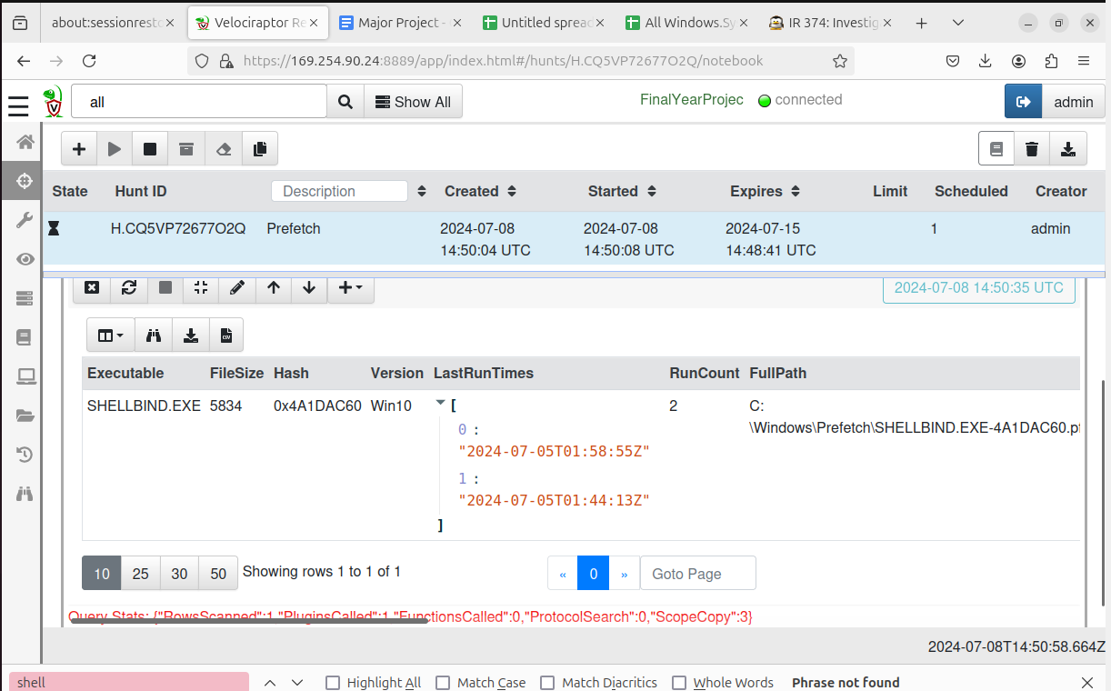

After running this artefact, notable pieces of data can be used to assist in the investigation.

Execution times. The “LastRunTimes” field shows when the “shellbind.exe” was executed and the data above provided us with two run times.

"2024-07-05T01:58:55Z"

"2024-07-05T01:44:13Z"

These timestamps can indicate the exact times the executable was run which can be used to help understand the time of the attack and help construct a timeline.

Run Count. The runcount field shows how many times the “shellbind.exe” has been executed. In the data, the run count is stated as 2. This information helps us understand the persistence and recurrence of the attack.

File Path and Hash. This information is able to provide us with the location and the prefetch file name for “shellbind.exe”

FullPath: C:\Windows\Prefetch\SHELLBIND.EXE-4A1DAC60.pf

PrefetchFileName: SHELLBIND.EXE-4A1DAC60.pf

This confirms the presence of the exact path of the executable which also helps aids in locating the file for further analysis.

FIle metadata

This information provides additional context about the file’s lifecycle on the system and the creation time is also able to indicate when the file was first written to the disk and modification time is also displayed.

CreationTime: 2024-07-05T01:44:24.6154296Z

ModificationTime: 2024-07-05T01:58:57.3530684Z

## Sysmon Logs

Now that we have metadata including execution times, creation times, and modification times, ,we are able to utilise the following artefact “Windows.EventLogs.Evtx” to narrow down the investigationm process to those times.

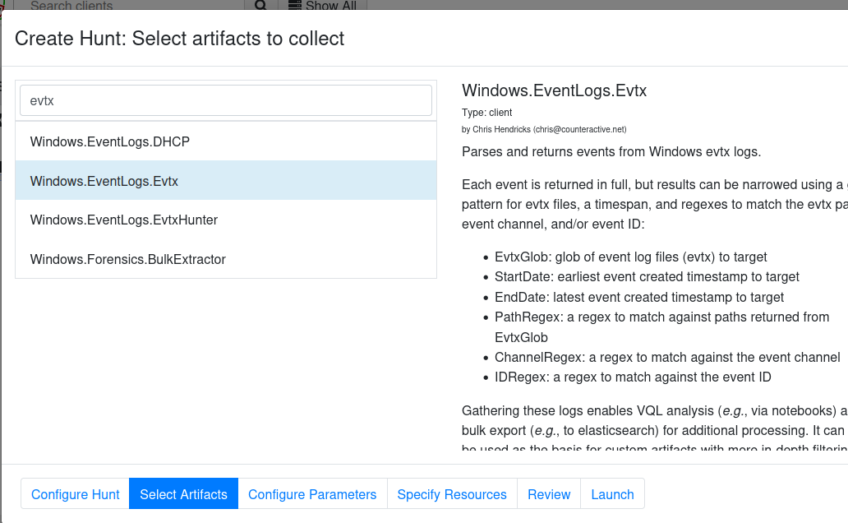

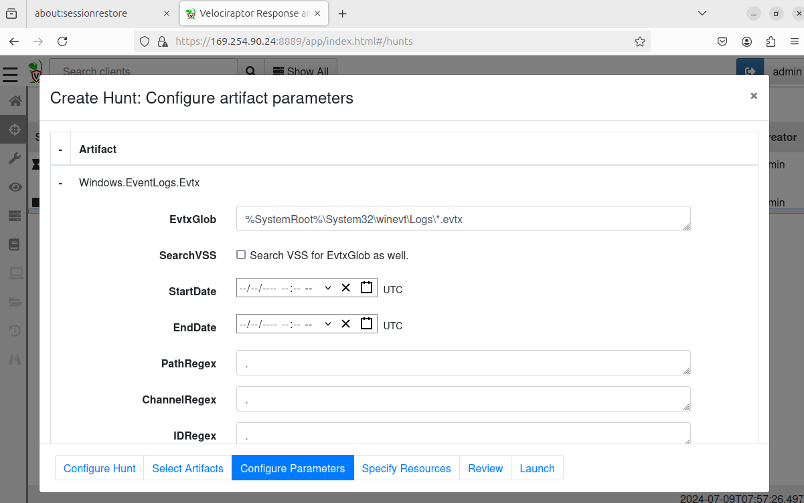

Utilising the artefact “Windows.EventLogs.Evtx”, configure the parameters of the start date and end date to narrow down the search for the most precise results.

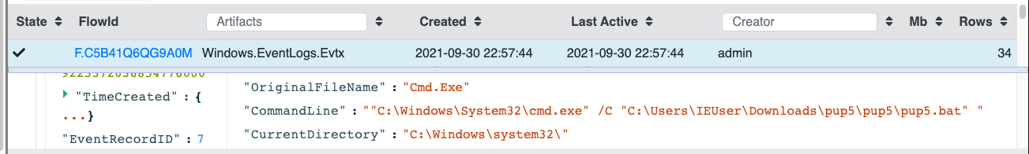



From the results shown above, the two events shows the user unzipping the file with 7z.exe and also Command Prompt opening when the pup5.bat is being run. The timestamps can also be found inside the “System” column.

## Quarantine and Containment

# 

The Windows.Remediation.Quarantine artifact in Velociraptor is designed to contain and mitigate malware threats on a Windows endpoint. It isolates suspicious files by moving them to a designated quarantine directory, preventing their execution while allowing for further analysis. Additionally, the artifact can terminate malicious processes, ensuring that they do not continue to run or spread.

To combat persistence mechanisms, it can modify or delete registry keys and other auto-start entries that the malware might use to restart after a system reboot.

The artifact also has the capability to apply network isolation, blocking the infected endpoint's communication with other systems to contain the spread of the malware. Furthermore, it logs all actions taken, providing an audit trail for analysis and verification. This tool is particularly useful during incident response to quickly neutralize active threats and in proactive containment strategies to manage potential risks identified during threat hunting or routine scans.

By employing the Windows.Remediation.Quarantine artifact, security teams can effectively manage and mitigate malware, aiding in the swift recovery and remediation of compromised systems.

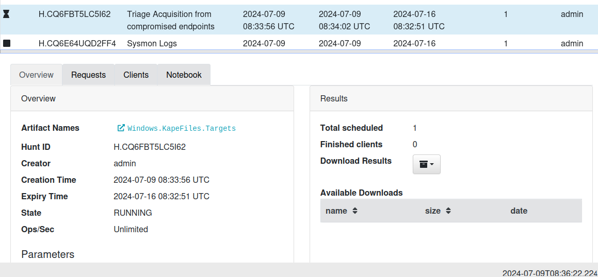

# 

Another method of containment and mitigation can be done by triaging acquisitions. This can be carried by running a hunt utilising the artefact “Windows.KapeFiles.Targets”. This artifcat leverages KAPE (Kroll Artifact Parser and Extractor) targets to swiftly collect specific forensic artifacts from a Windows system, facilitating rapid identification of malicious activities and enabling immediate containment actions.

Targeting critical forensic artifacts such as event logs, registry hives and prefetch files, it helps build a comprehensive picture of system’s state and any activity which deemed to be suspicious.

References:

<https://dfrws.org/wp-content/uploads/2021/03/DFRWS-EU-2021-Velociraptor-Digging-Deeper.pdf>

<https://youtu.be/Q1IoGX--814?si=STBQWcdUdYryjQtl> → live incident response

[https://www.youtube.com/watch?v=V268q1nKn1c&t=32](https://www.youtube.com/watch?v=V268q1nKn1c&t=327s)

[https://www.nerium.nl/blog/tracking-an-adversary-in-real-time-using-velociraptor-part-ii–](https://www.nerium.nl/blog/tracking-an-adversary-in-real-time-using-velociraptor-part-ii%E2%80%93) > Alerts

To be done:

Integrate hayabusa (<https://docs.velociraptor.app/exchange/artifacts/pages/windows.eventlogs.hayabusa/>

Setting Up Alerts